Management Control System

Software Training Materials

**Table of Contents**

1. INTRODUCTION OF MANAGEMENT CONTROL SYSTEM 2

2.

# 1. INTRODUCTION OF MANAGEMENT CONTROL SYSTEM

……….

….

…….

…….

…….

The link for MCS is <http://192.168.3.7:3000/> which is accessible within BBA’s local network. After a search will open a login page. Which is like –

### How to Log in to the MCS

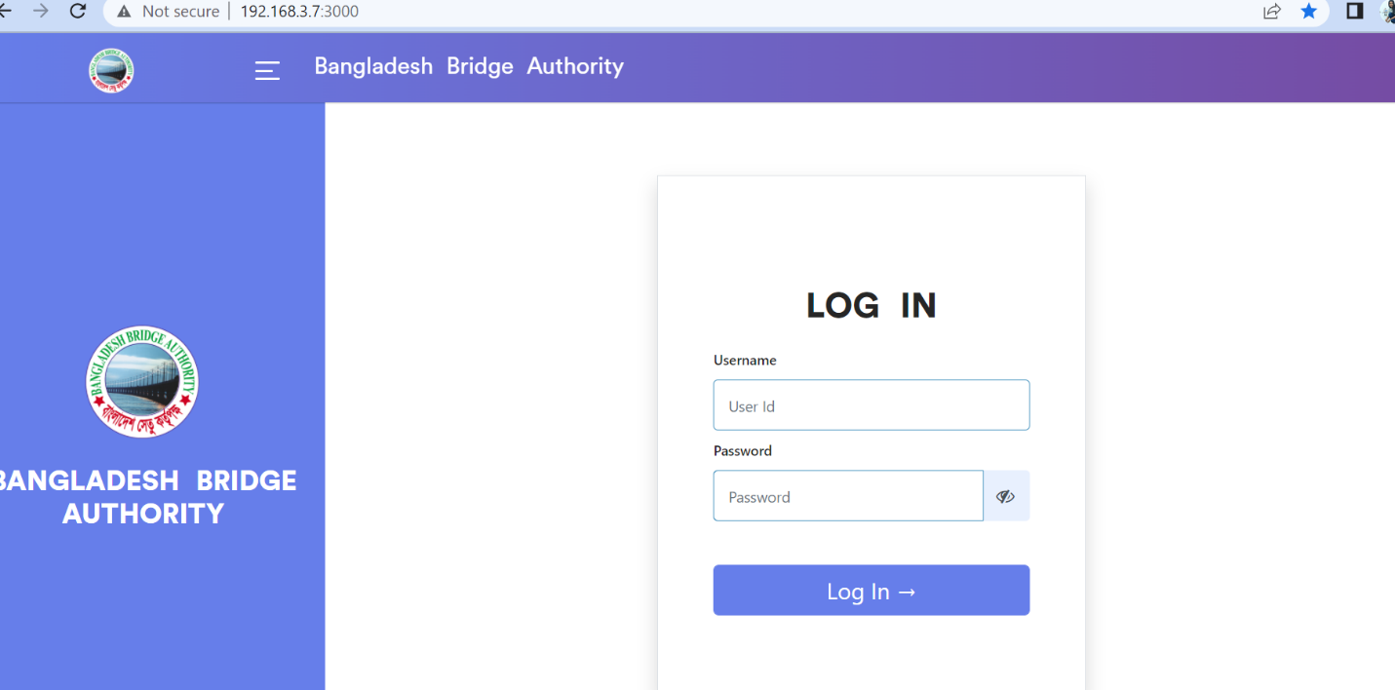

Figure : Log in Page

**Steps to Log in to MCS**

1. User will input his Username
2. User will input his Password
3. Click Log In Button

If the username & password are correct, users will get access to the system.

# 2. Administration Wing

For the Administration module –

**Steps to Enter in Administration**

1. After login will show this dashboard of MCS.

2. Click on Administration.

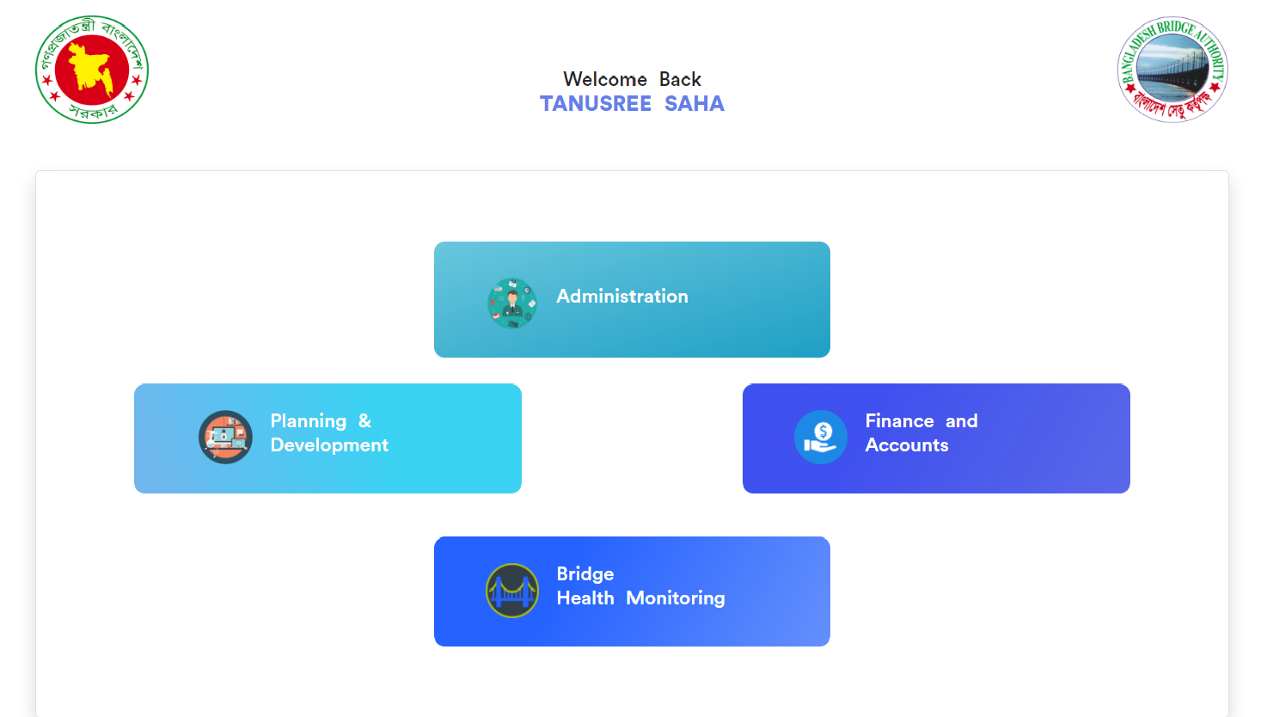

Figure 2: Dashboard of MCS

After entering into Administration will show another dashboard with another five (5) Submodules. Such as-

1. Human Resource
2. Estate
3. Transport
4. IT
5. Store

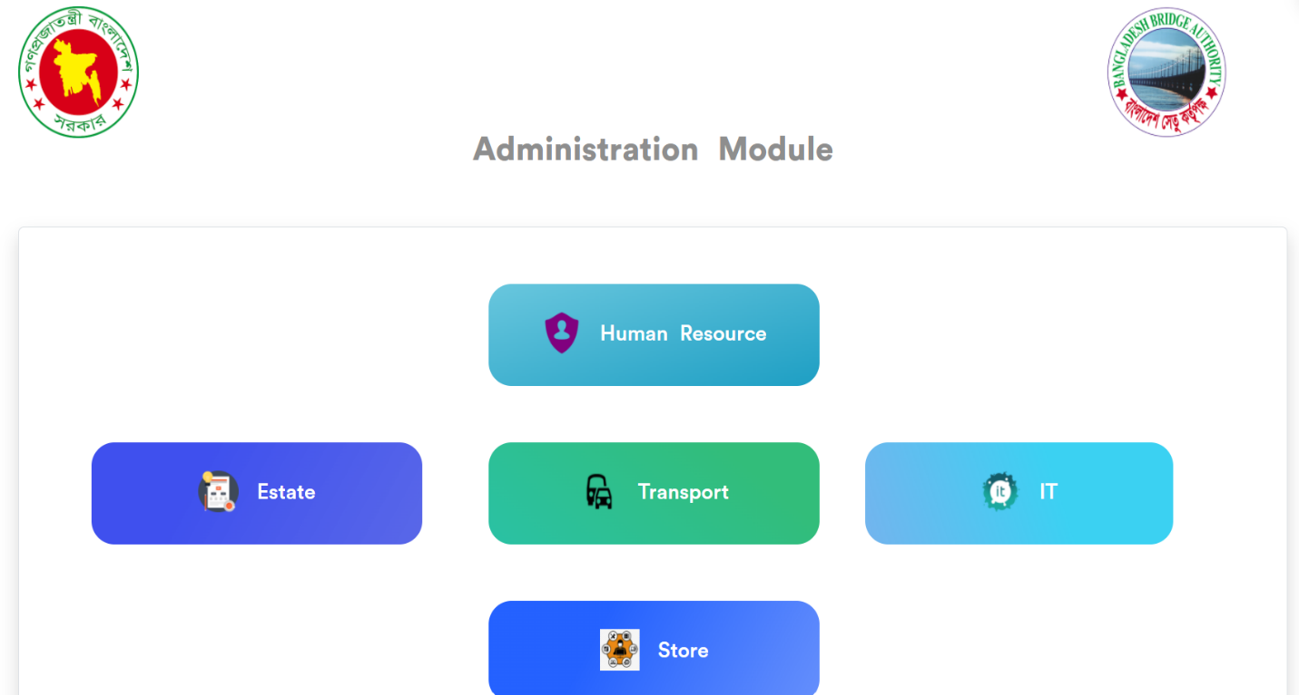

Figure 4: Dashboard of Administration Module.

1. **Administration >** **Human Resource**

* Click on Human Resource
* Will get another dashboard of Human resources with some menus.

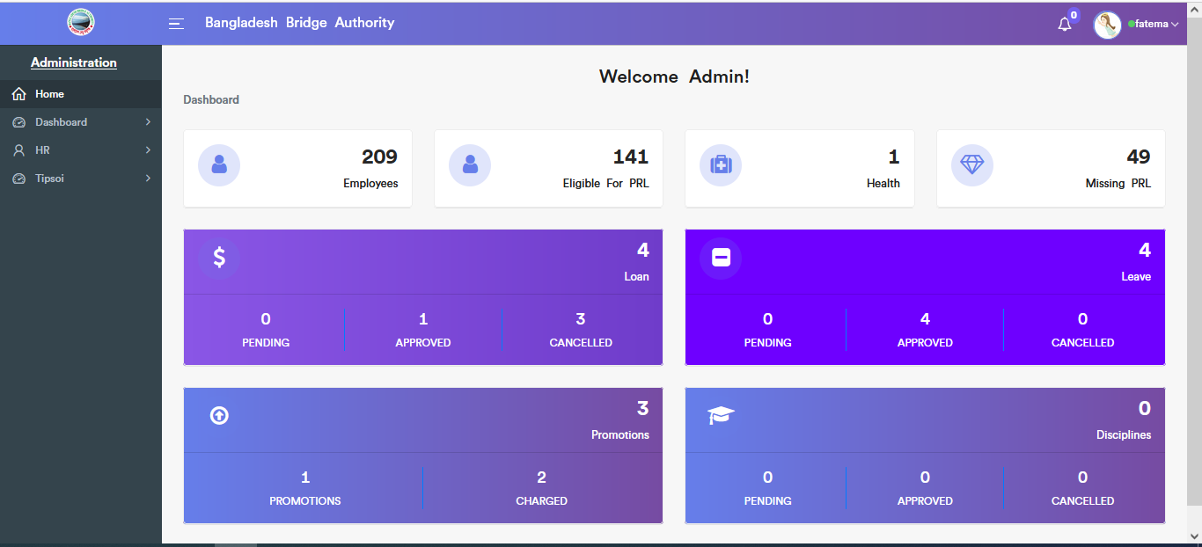

There have 3 menus. Such as-

1. Dashboard
2. HR
3. Tipsoi

**Administration >** **Human Resource > Dashboard**

Click on Dashboard there has 2 sub-menus. These are-

1. Admin Dashboard
2. Employee Dashboard

**Administration >** **Human Resource > Dashboard > Admin Dashboard**

Here we can see all Employee’s information at a glance.



**Administration >** **Human Resource > Dashboard > Employee Dashboard**

Here we can see all Employee’s Loan, Leave, and Promotions information at a glance.

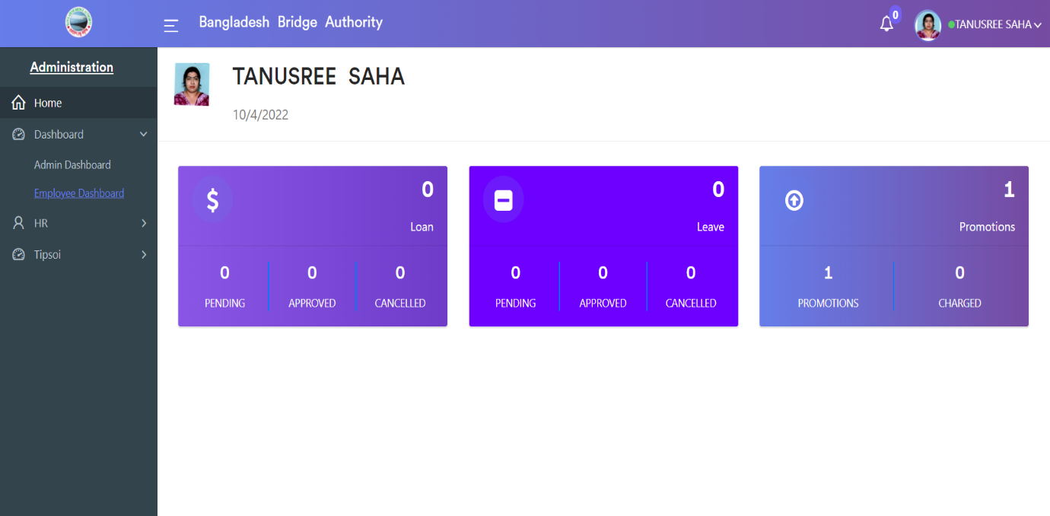

**Administration >** **Human Resource > HR**

Click on HR there has 7 sub-menus. These are-

1. Employees
2. Loan
3. Leave
4. Health
5. Discipline
6. Events
7. Settings

**Administration >** **Human Resource > HR > Employees**

After Clicking on Employees there has 5 sub-menus. These are-

1. All Employees
2. Education
3. Children
4. Promotion / Charge
5. Training

**1. All Employees:** After clicking on **Administration > Human Resource > HR > Employees > All Employees**. This employee module gives details about the employees working in the BBA and also about all the employee information.

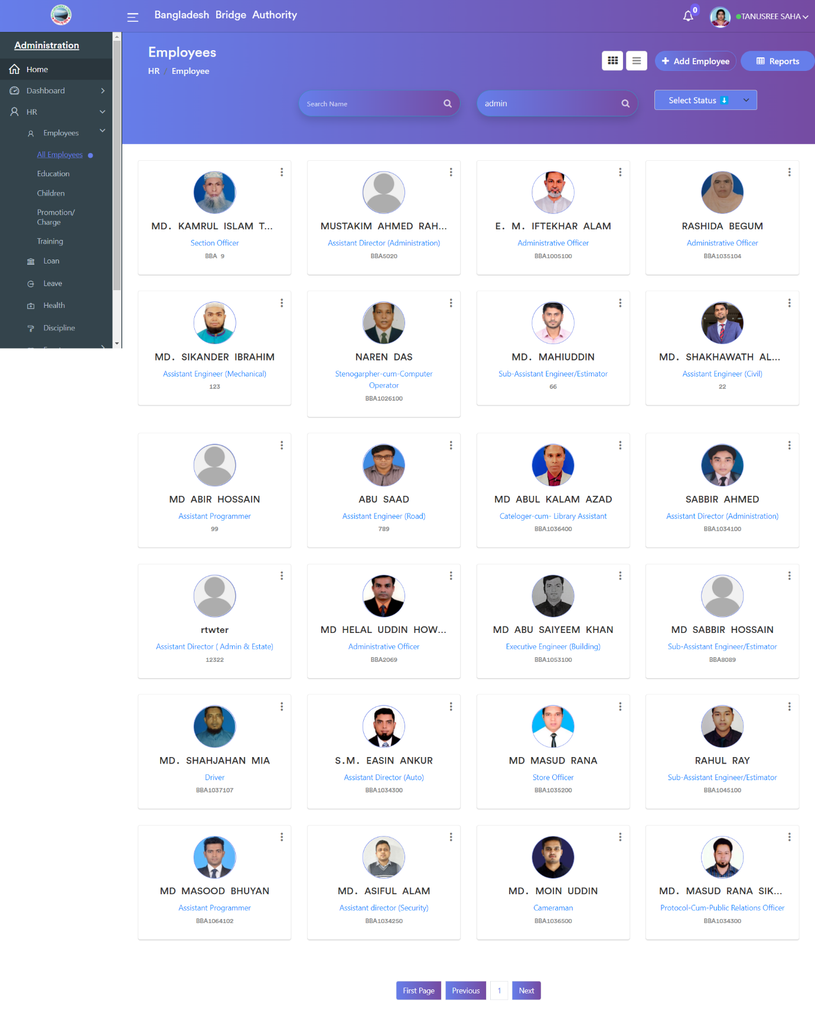

Click on the “Add Employee” button to create a new employee record. There we can add various information that is related to the employee. There have various pages clicking ‘Next’ we can enter the basic information such as the Employee details, Job details, General, Emergency contacts, etc.

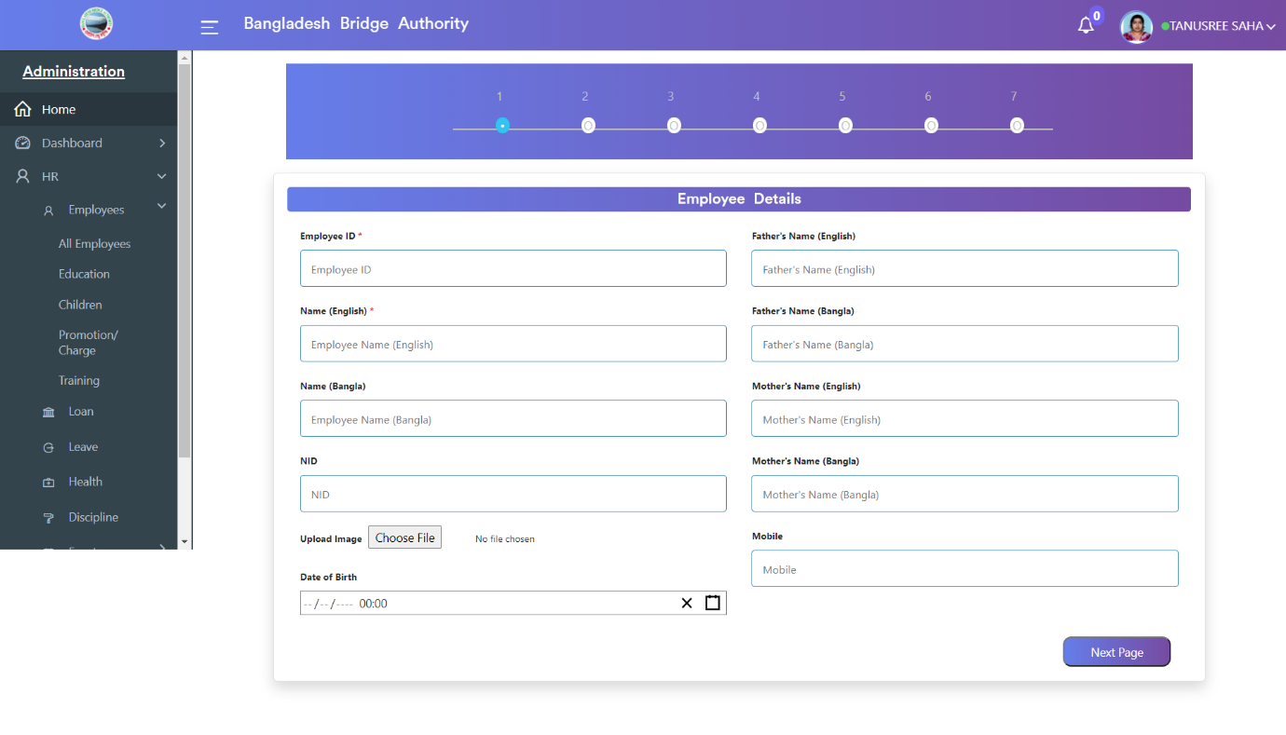

Click on the “Reports” button we can see all employee’s reports. Here we can download the employee’s record in Excel or PDF format.

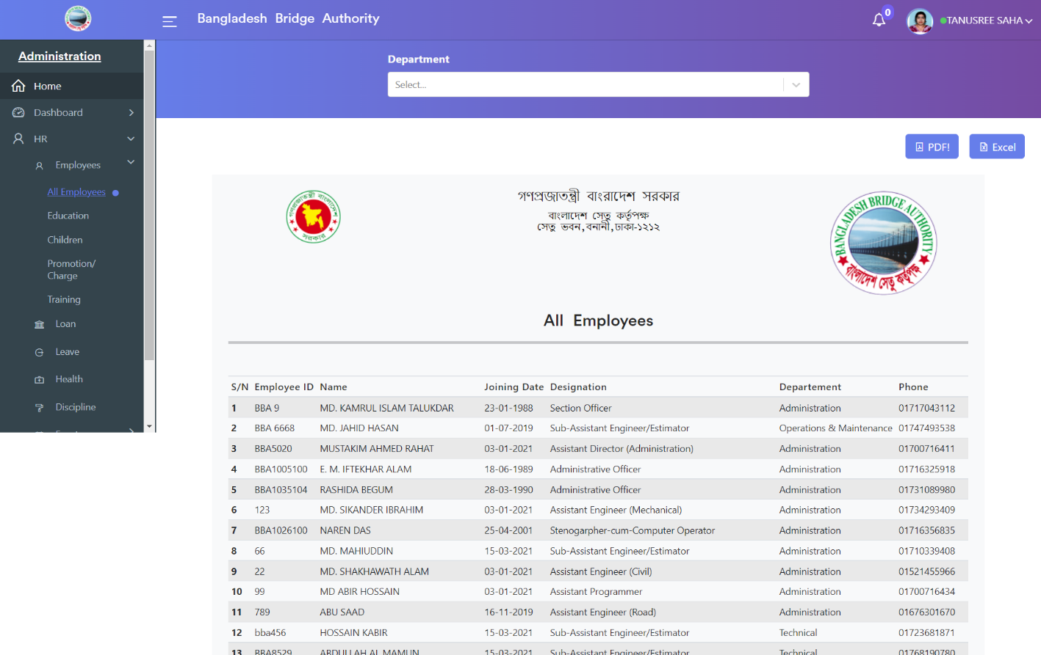

**2. Education:** After clicking on **Administration > Human Resource > HR > Employees > Education**. This module gives details about the employee’s educational information

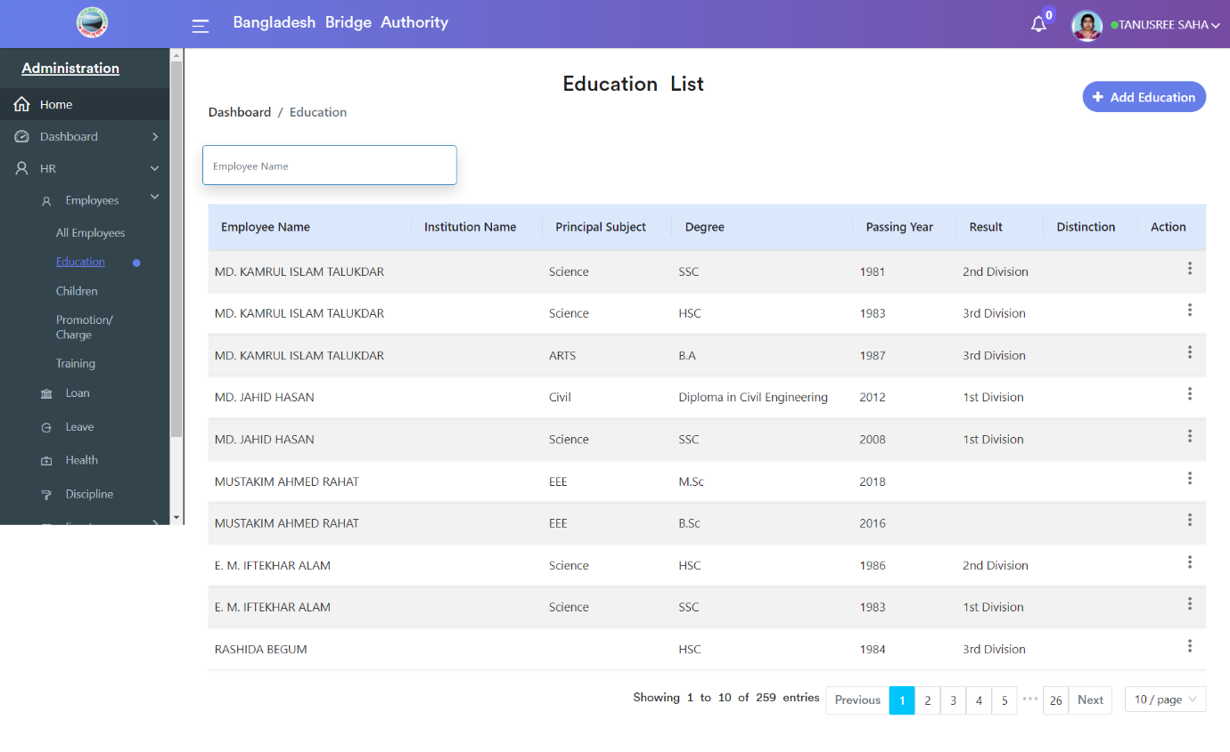

Click on the “Add Education” button to create a new employee educational record. There we can add various information that is related to the employee’s education.

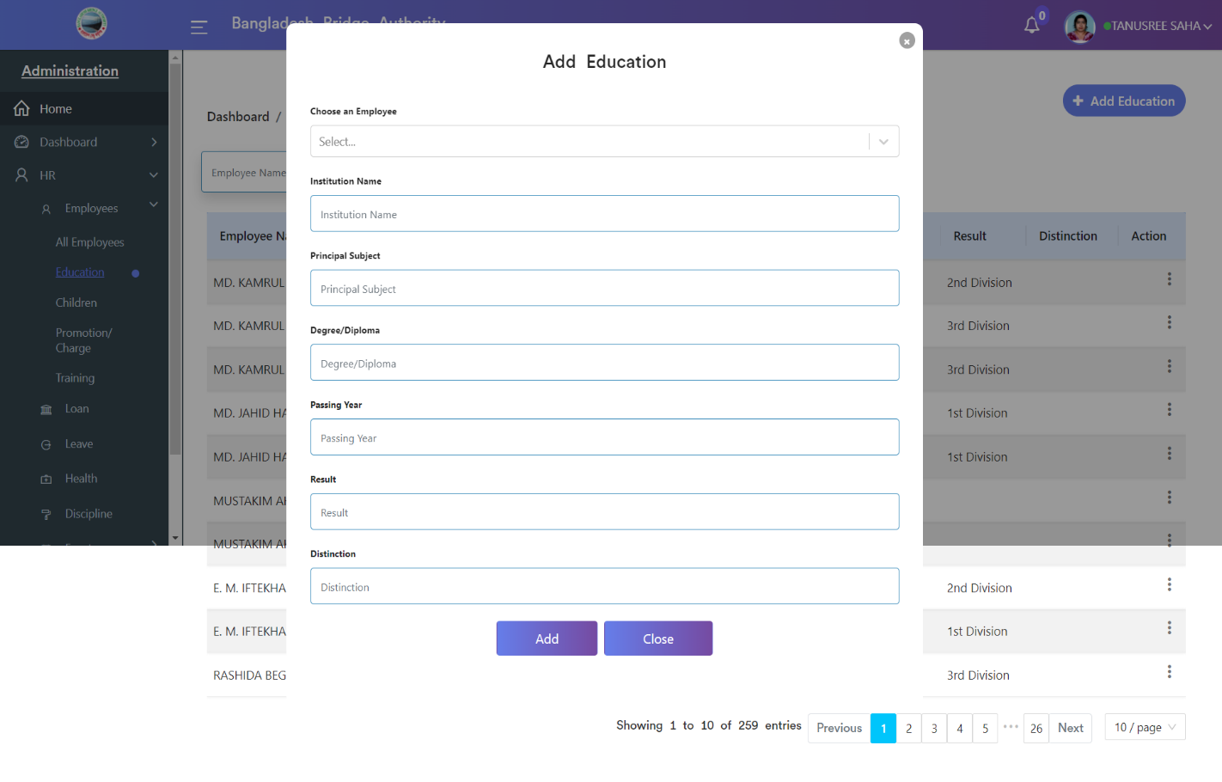

**3. Children:** Clicking on **Administration > Human Resource > HR > Employees > Children**. This module gives details about the employee’s children’s information.

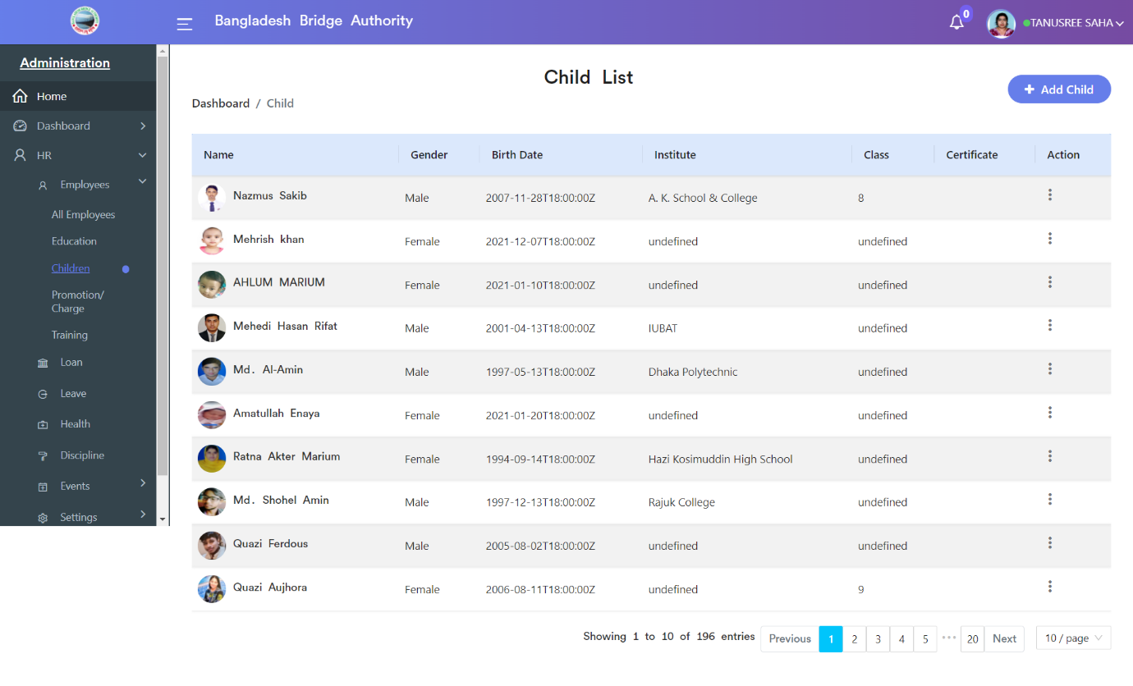

Click on the “Add Children” button to create a new employee children record. There we can add various information that is related to the employee’s children.

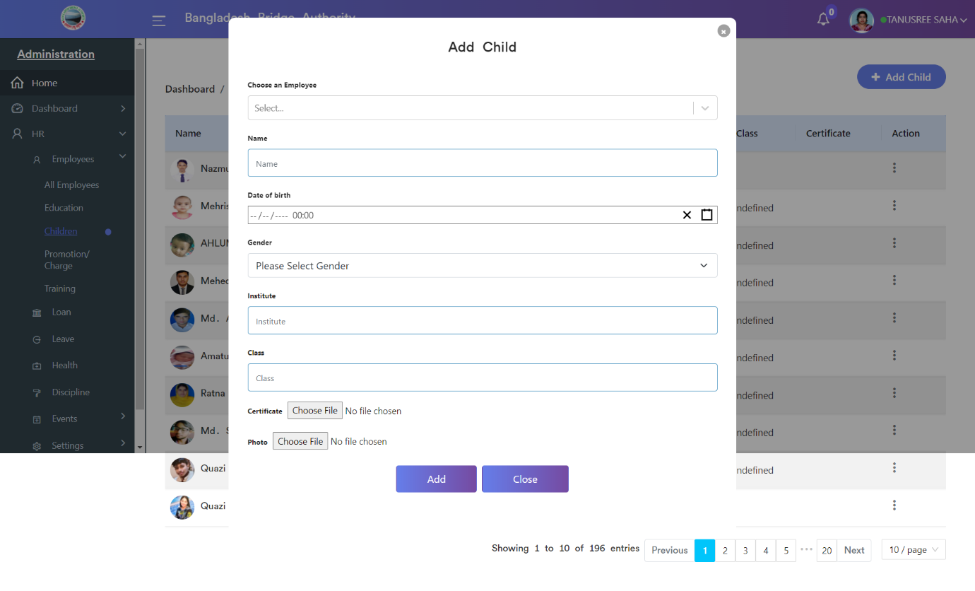

**4. Promotion / Charge:** Clicking on **Administration > Human Resource > HR > Employees > Promotion / Charge**. This module gives details about the employee’s promotion information.

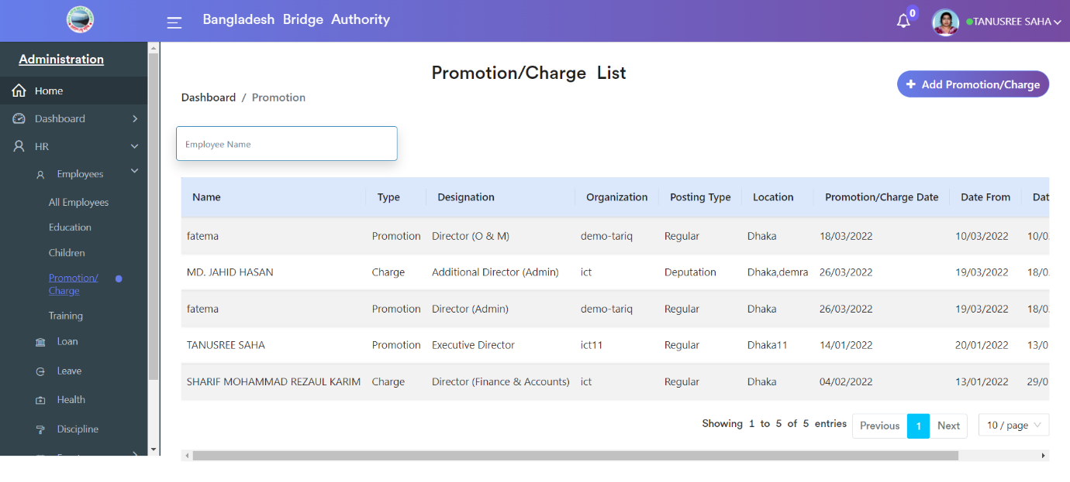

Click on the “Add Promotion/Charge” button to create a new employee Promotion/Charge record. There we can add various information that is related to the employee’s Promotion/Charge

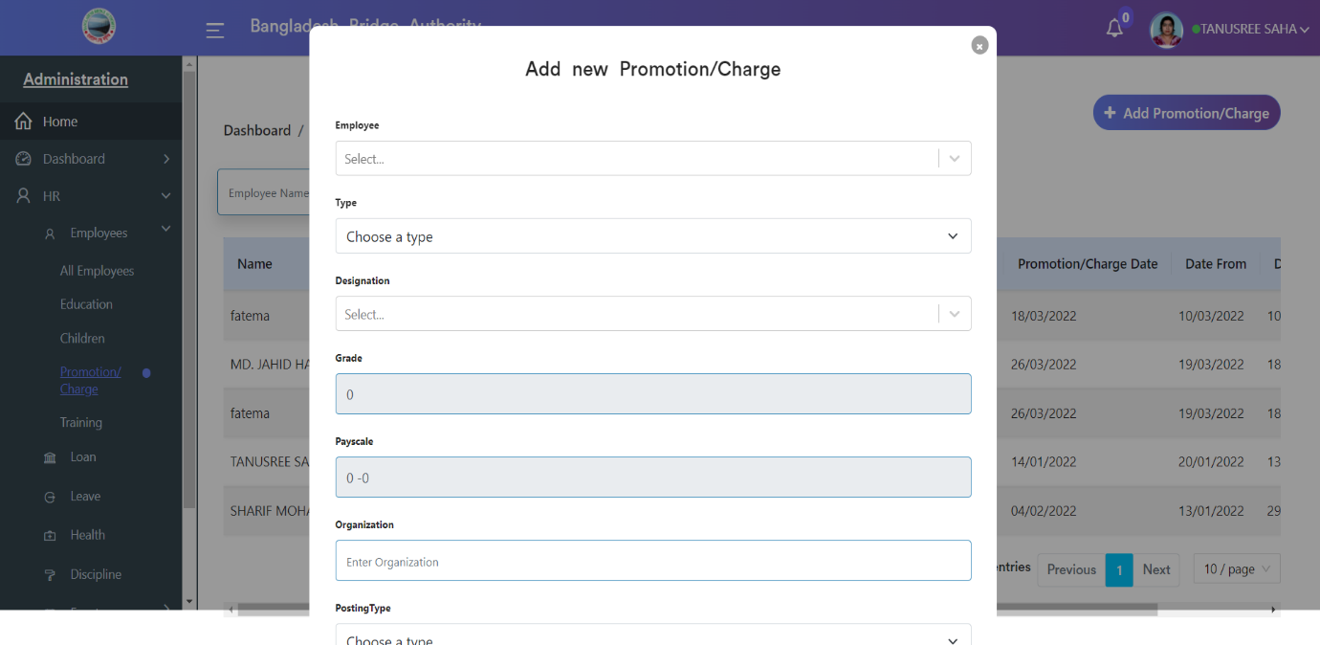.

**5. Training:** Clicking on **Administration > Human Resource > HR > Employees > Training**. This module gives details about the employee’s training information.

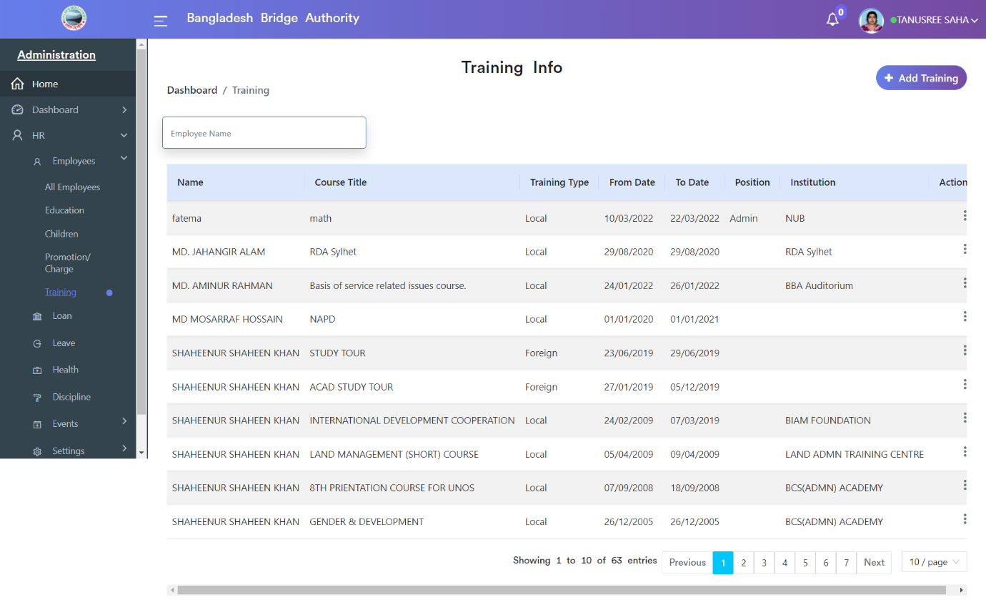

Click on the “Add Training” button to create an employee Training record. There we can add various information that is related to the employee’s Training.

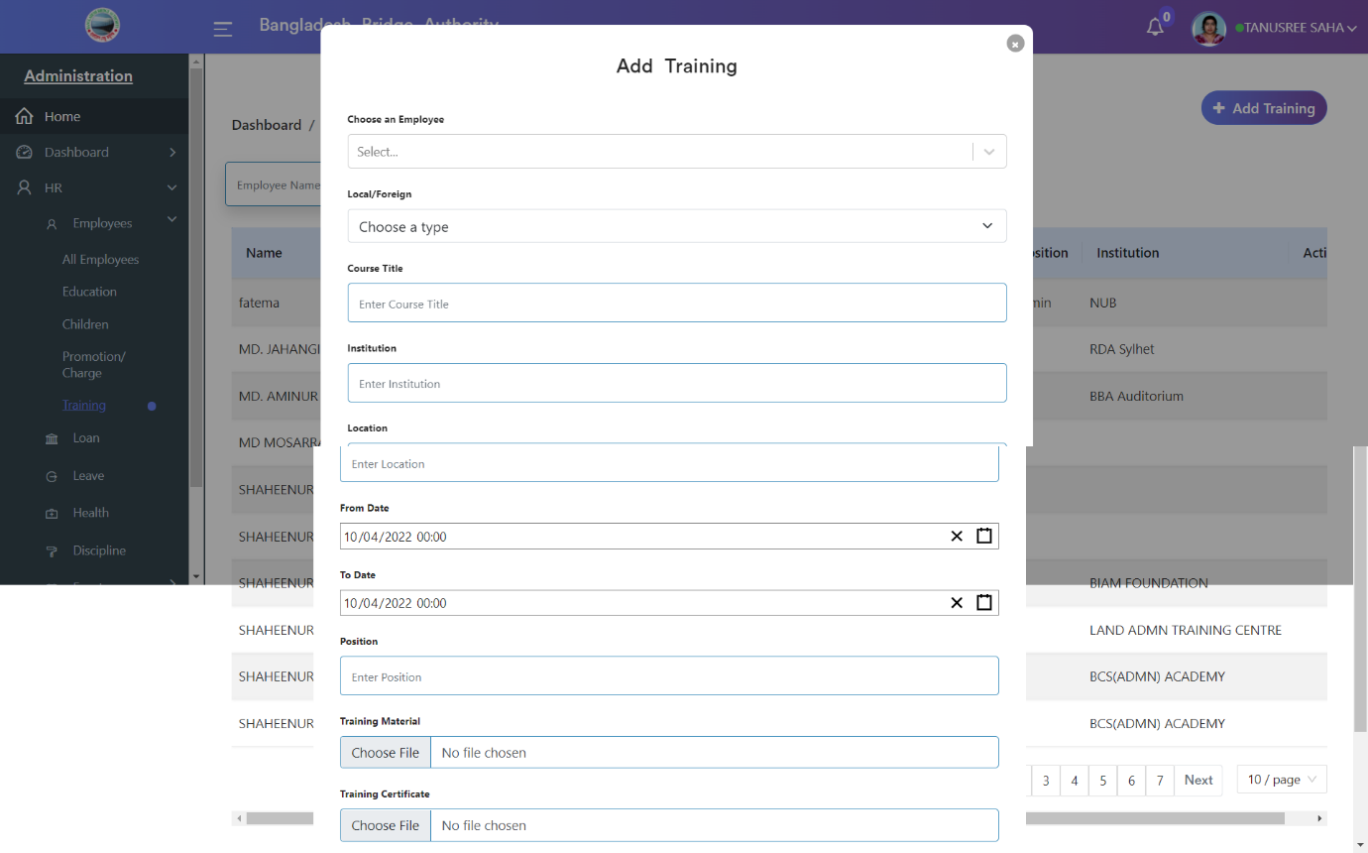

**Administration >** **Human Resource > HR > Loan**

Employees can apply for loans using the loan page with details such as loan amount, installment, sanction date, number of installments month, source of funds, etc.

Use the Employees > Loan > Employee Loan Request for Loans to see the list view of the Loan requests.

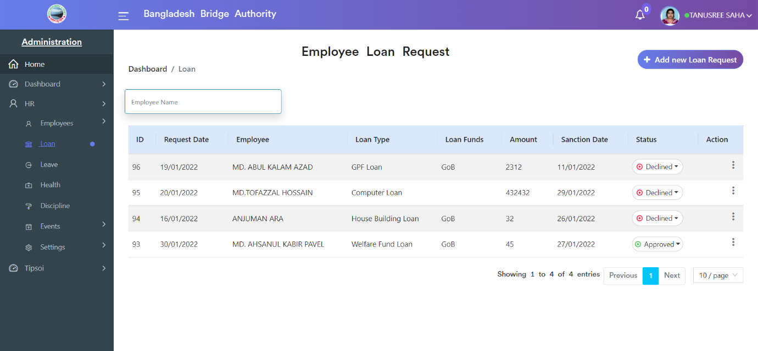

>> Click on the ‘Add new Loan Request’ button to create a new Loan request. Select the employee and fill in other details such as the loan amount, Loan Termination Date, etc. Then we can submit the request and wait for the approval.

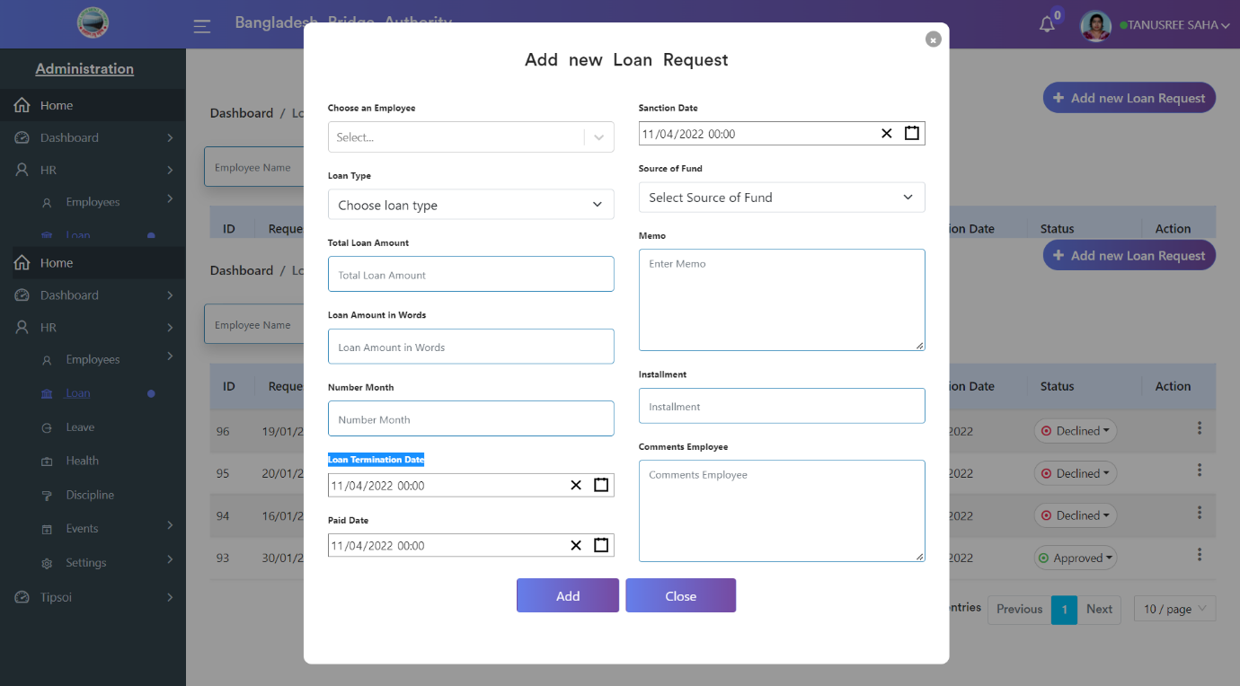

**Administration >** **Human Resource > HR > Leave**

Here the leave page deals with employee leaves and related activities.

Use the Employees > Leave > Employee Leave Request for leave to see the list view of the Leave requests.

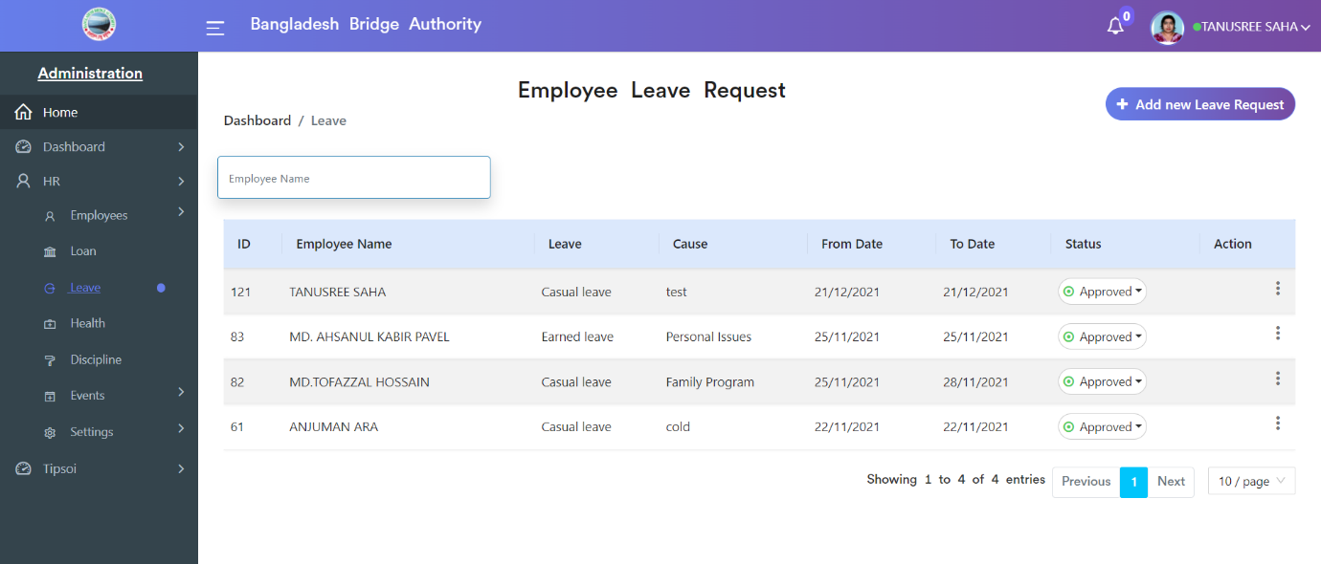

>> Click on the ‘Add new Leave Request’ button to create a Leave request. Select the employee and fill in other details such as the From Date, To Date, Name of Leave, Cause, etc. Then we can submit the request and wait for the approval.

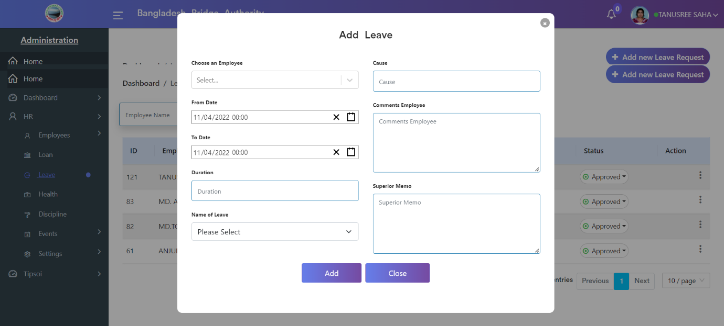

**Administration >** **Human Resource > HR > Health**

This page shows employees’ health records and related activities.

Use the Employees > health > Health Records for health to see the list view of the health records.

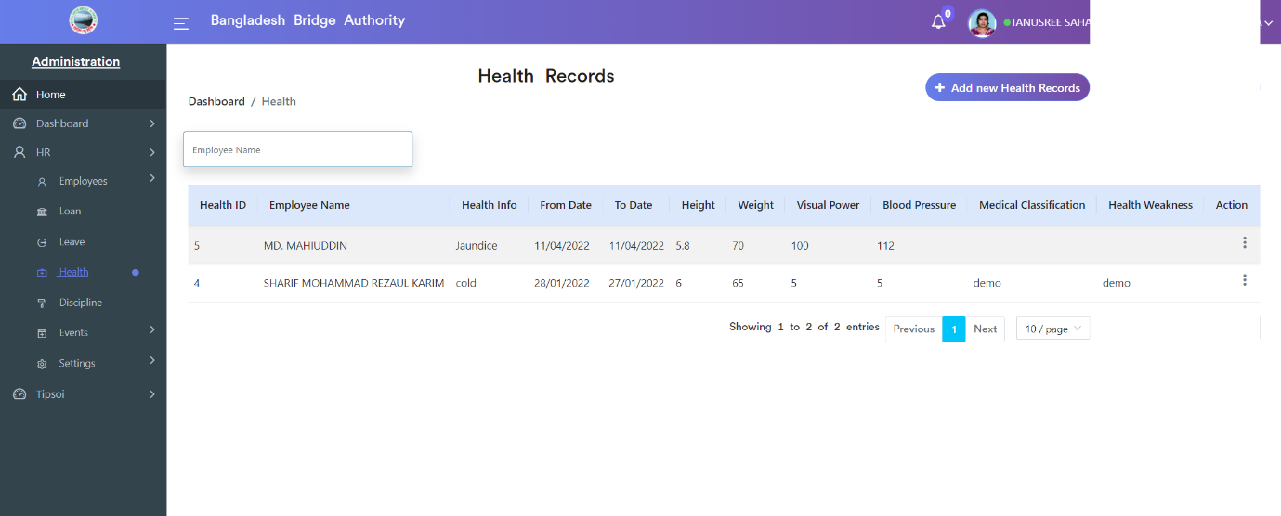

>> Click on the ‘Add new Health Records’ button to create a Health record. Select the employee and fill in other details such as the Weight, Height, Visual Power, X-ray Report, ECG Report, Blood Pressure, etc. Then we can submit the record.

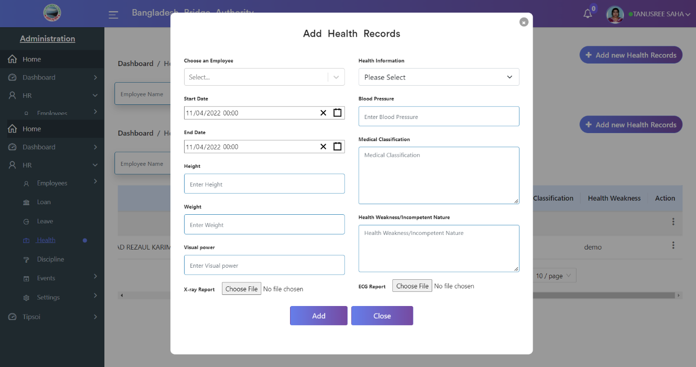

**Administration >** **Human Resource > HR > Discipline**

This page shows employees’ punishment records and related activities.

Use the Employees > health > Disciplines for punishment to see the list view of the punishment records.

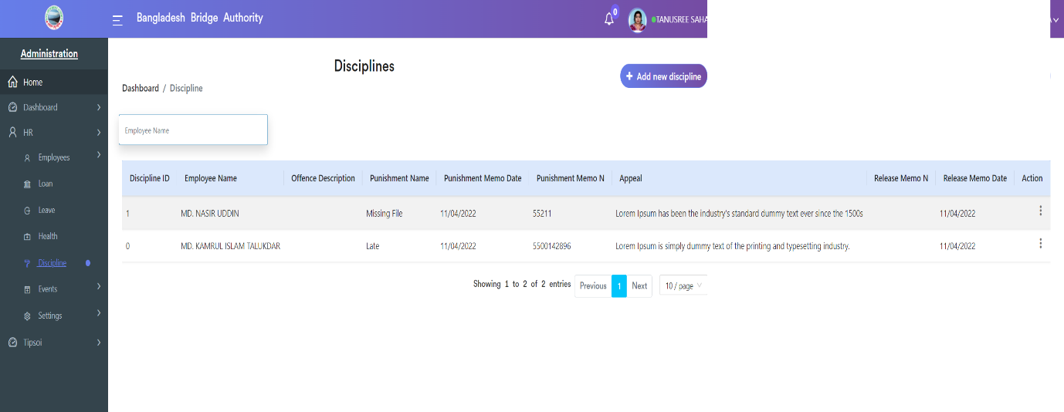

>> Click on the ‘Add new Discipline’ button to create an employee’s Punishment record. Select the employee and fill in other details such as the Name of Punishment, Punishment Memo No, Description of Offence, Type of Punishment, Appeal, etc. Then we can submit the record.

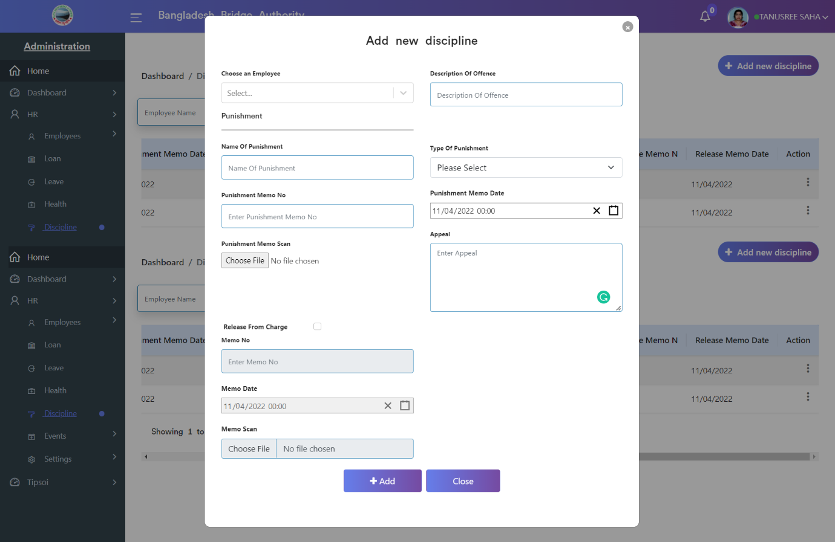

**Administration >** **Human Resource > HR > Events**

After Clicking on Events there has 3 sub-menus. These are-

1. Dashboard
2. Calendar
3. Event

**1. Dashboard:** After clicking on **Administration > Human Resource > HR > Events > Dashboard**. The event dashboard gives details about the employee’s events in the BBA and also about all of the event’s information at a glance.

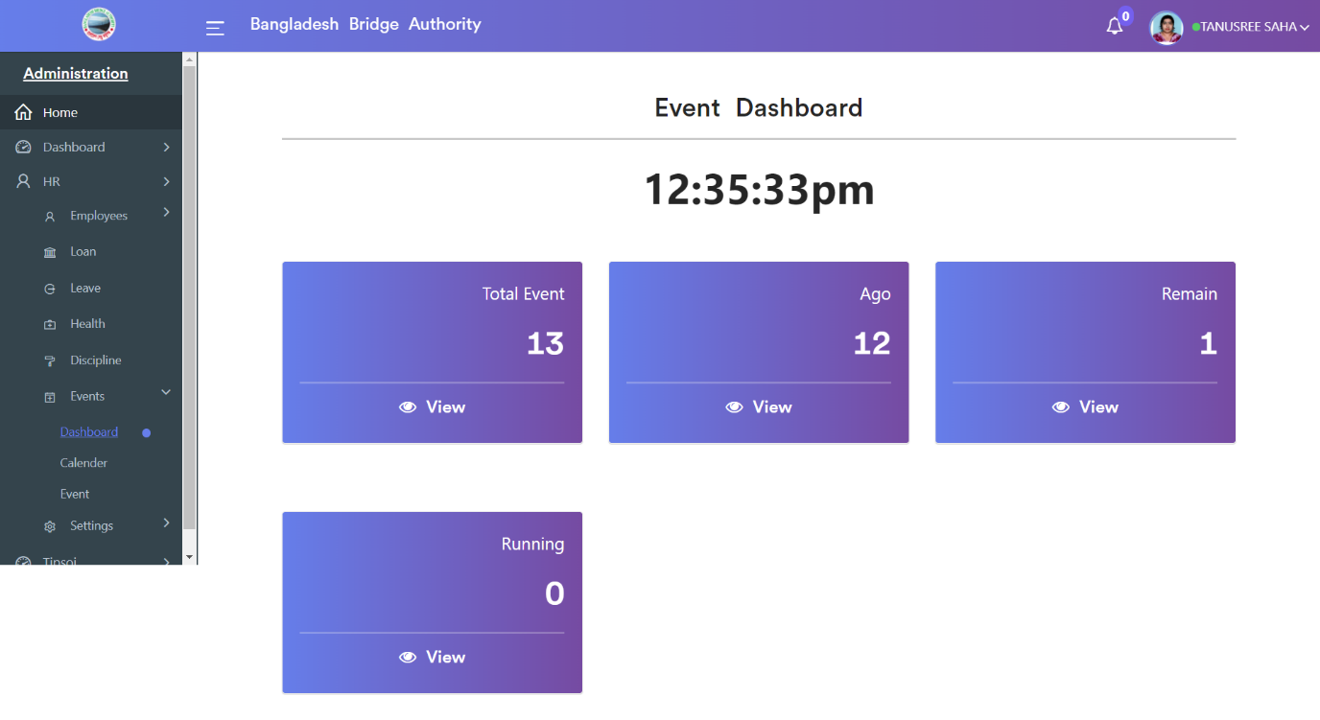

**2. Calendar:** After clicking on **Administration > Human Resource > HR > Events > Calendar**.  It allows you to have a detailed in-hand calendar which can be of great usage for events. The calendar can be viewed as a day, week, or month. The events we added will be visible in all calendars whether it is day, week, or month.

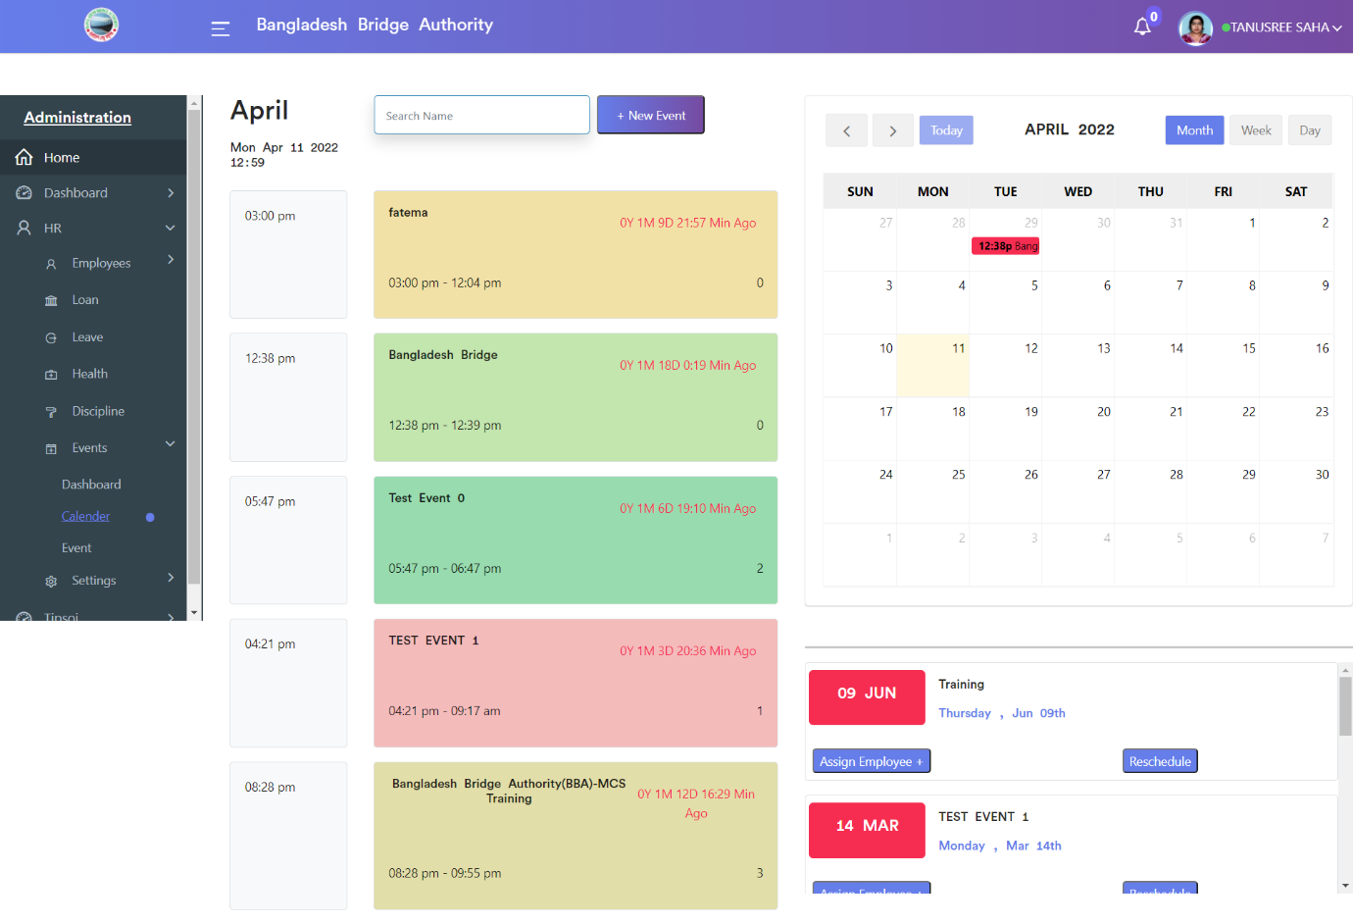

**3.Event:** Clicking on **Administration > Human Resource > HR > Events > Event**. This page shows employees’ events records. Here we can see the list view of the events records. In the action tab using ‘Assign Employee’ link, we can add event employees.

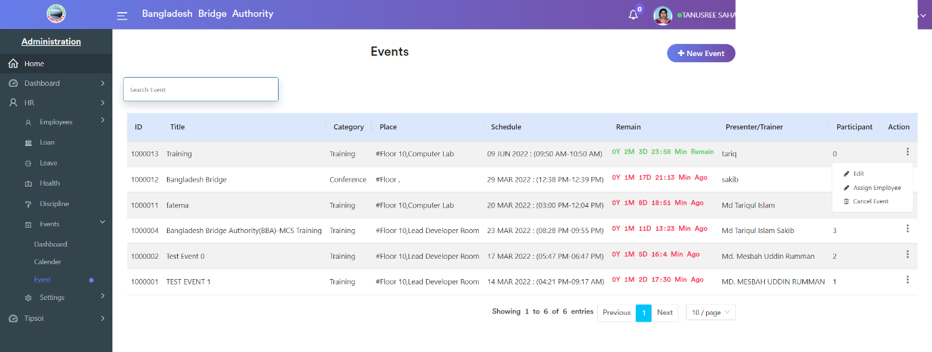

>> Click on the ‘New Event’ button to create an employee’s event record. Fill in the details information such as the Event Title, Event Category, Department, Presenter/Trainer, Start Date, etc. Then we can save the record.

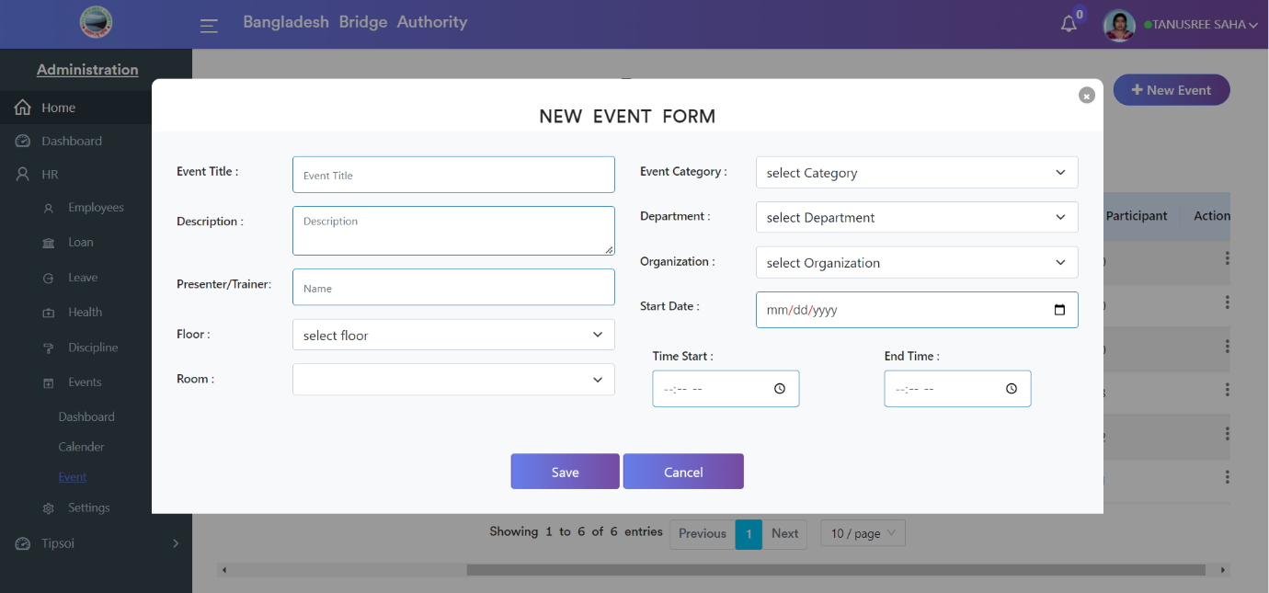

**Administration >** **Human Resource > HR > Settings**

Open the ‘Settings’ application for configuring various settings of the Human Resource.

There have several options. Such as-

1. Roles & Permissions
2. Users
3. Loan Types
4. Document Type
5. Health Information
6. Punishment
7. Departments
8. Designation
9. District
10. Loan Funds
11. Leave Types
12. Grades
13. ACRClass
14. ACRTypes
15. **Roles & Permissions:** Clicking on **Administration > Human Resource > HR > Settings> Roles & Permissions**. In the right side of this sub-menu there have three sections such as Roles,Program, and Program access.

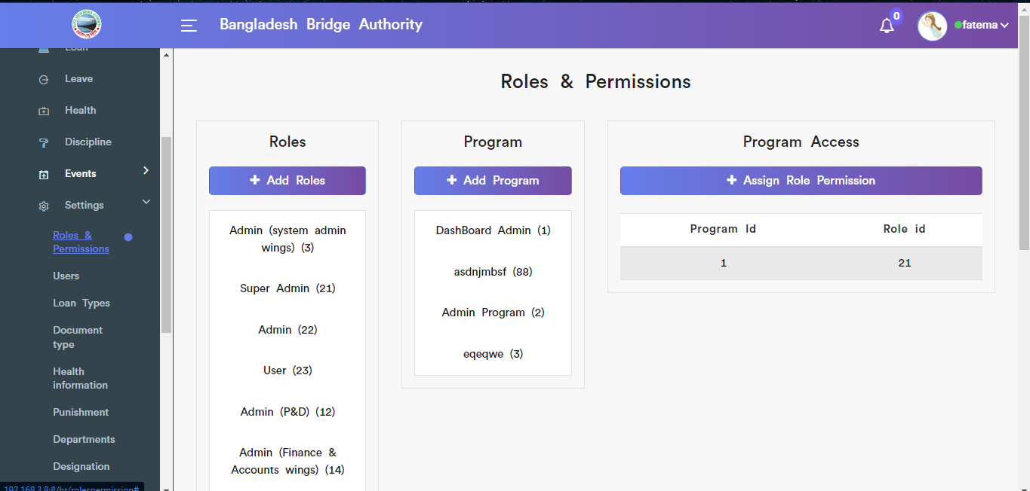

Figure: View roles & Permissions sub-menu

To Assign new role click on the ‘Add Roles’ button & fill in the required input filed with appropriate values.

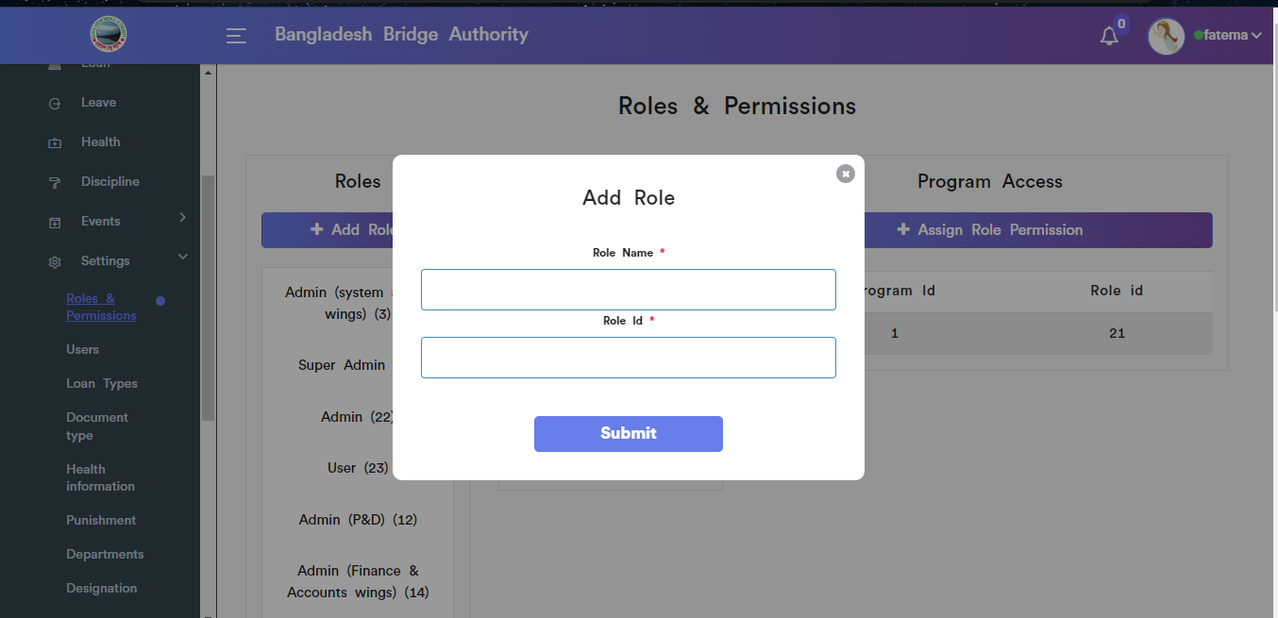

Figure: Add role input field

To add new program click on the ‘Add Program’ button & fill in the required input filed with appropriate values.

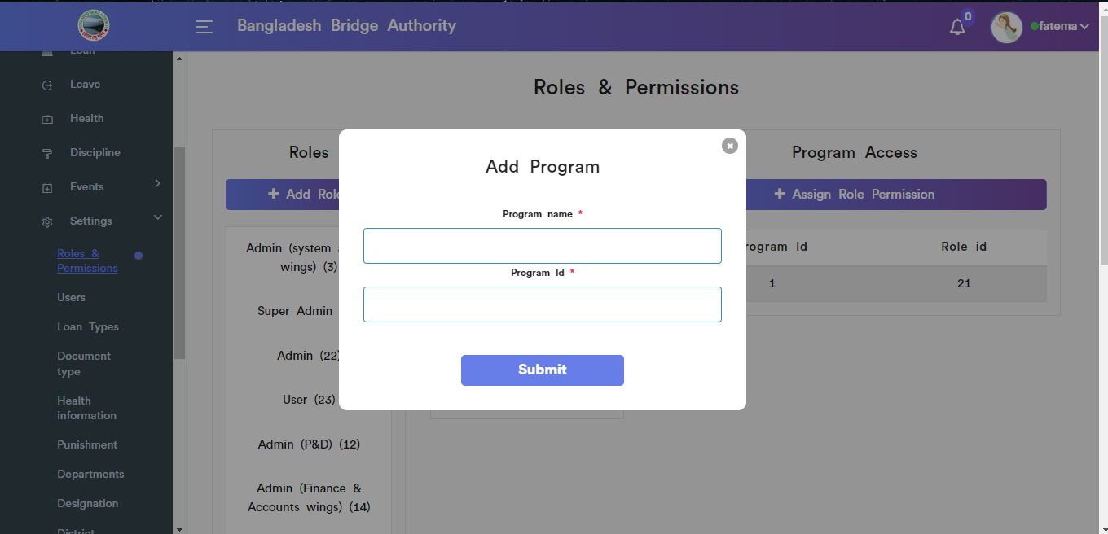

Figure: Add Program input field

To Assign Role Permission click on the ‘Assign Role permission’ button & fill in the required input filed with appropriate values.

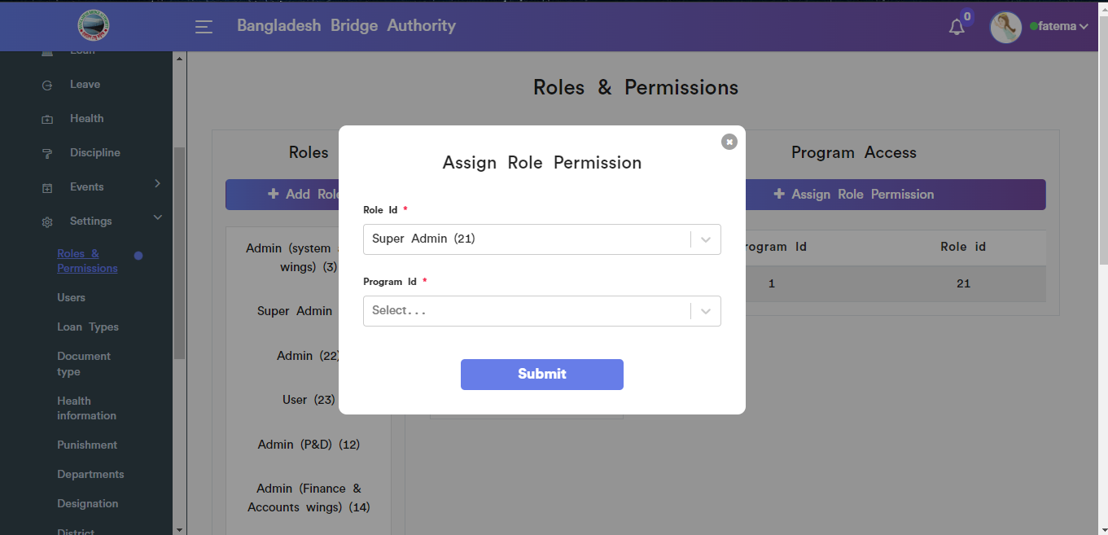

Figure: Assign role permission input field

1. **Users:** Clicking on **Administration > Human Resource > HR > Settings> Users**. From this sub-menu we can add users to play a specific role ,view all user’s roles,Search, and have the accessibility to edit ,change passwords & delete user .

To Assign new role to user click on the ‘Add User’ button & fill in the required input filed with appropriate values.

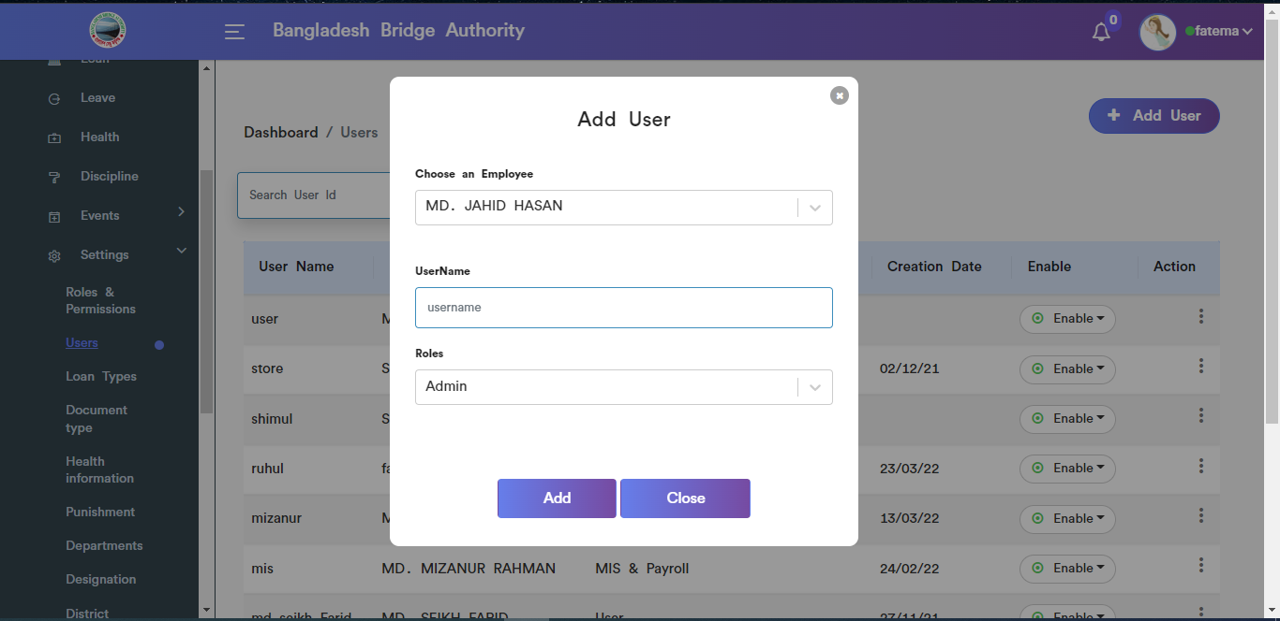

Figure: Add user input field

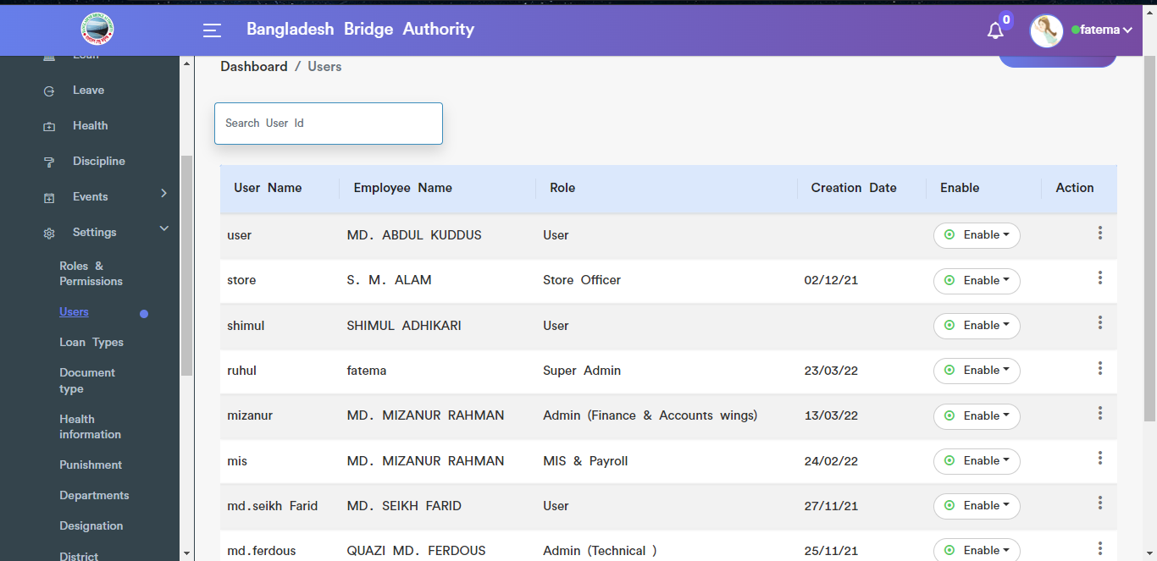

Figure: View details of user’s Role

Sequentially to complete edit ,password & delete functionality just do as like you see on the image scenario.

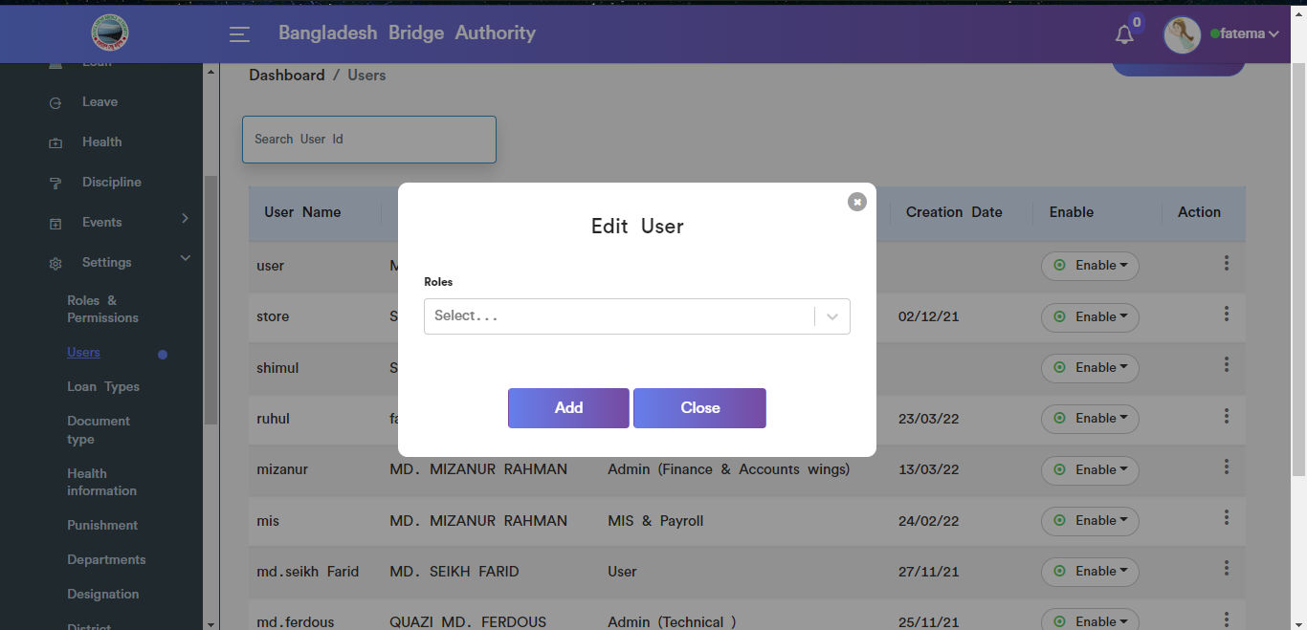

Figure: Edit user input field

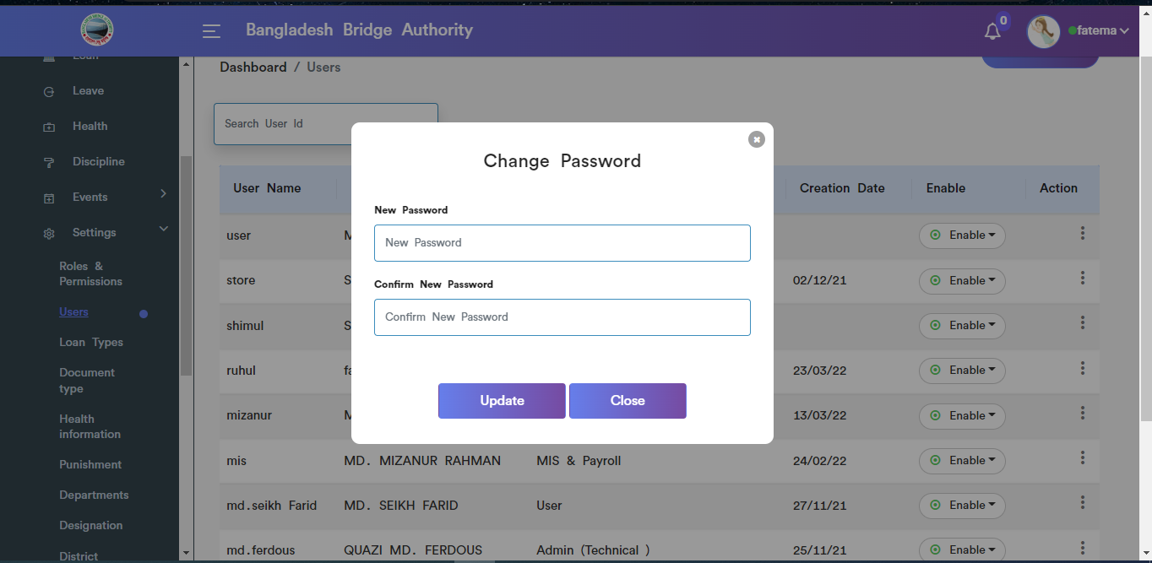

Figure: Change password input field

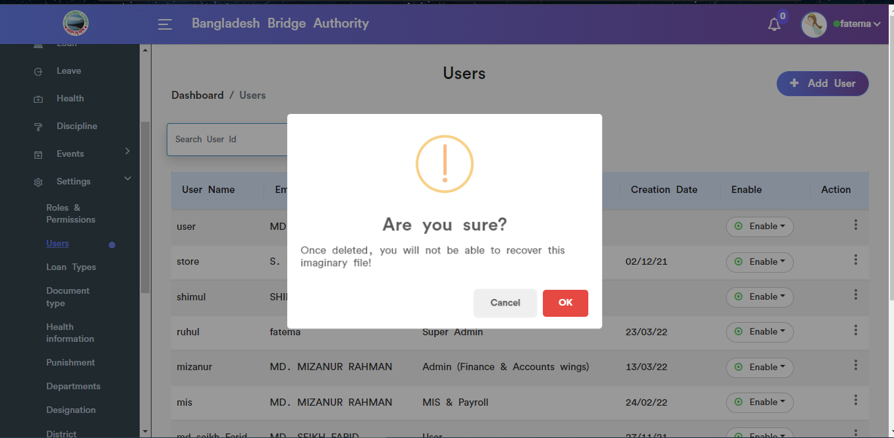

Figure: User data deleted functionality

1. **Loan Types:** Clicking on **Administration > Human Resource > HR > Settings> Loan Types**.This page allow to add loan type ,view loan type & Search, Edit, Delete.

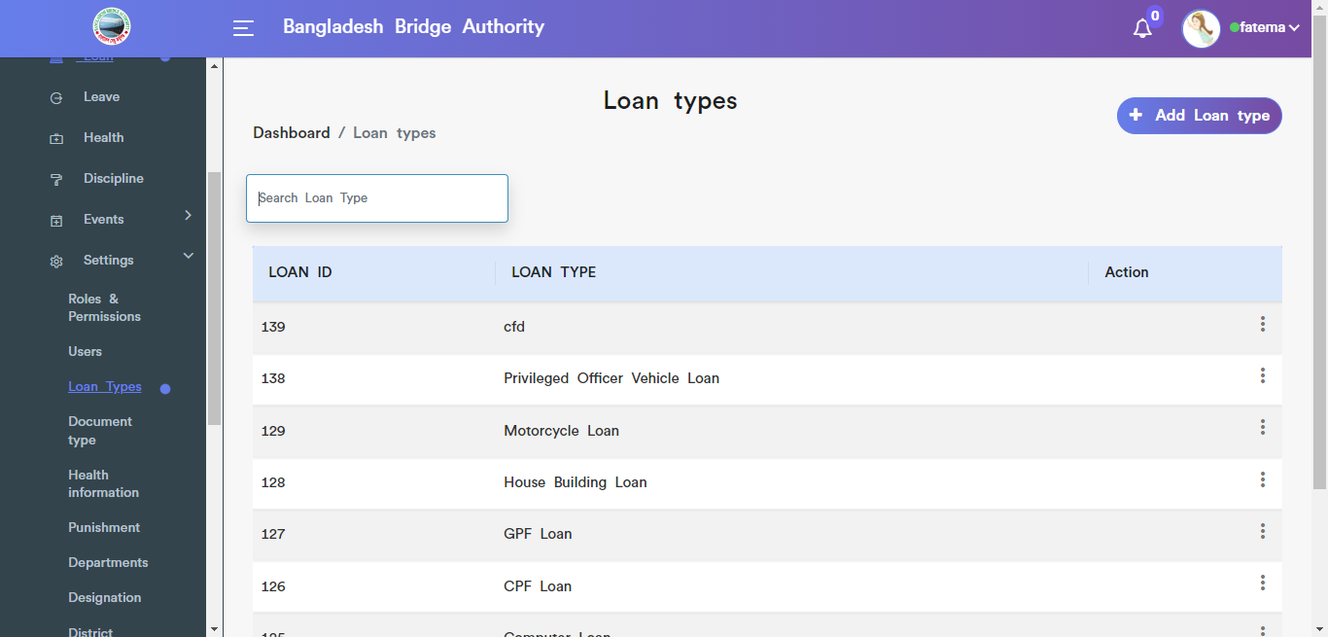

Figure: view loan type

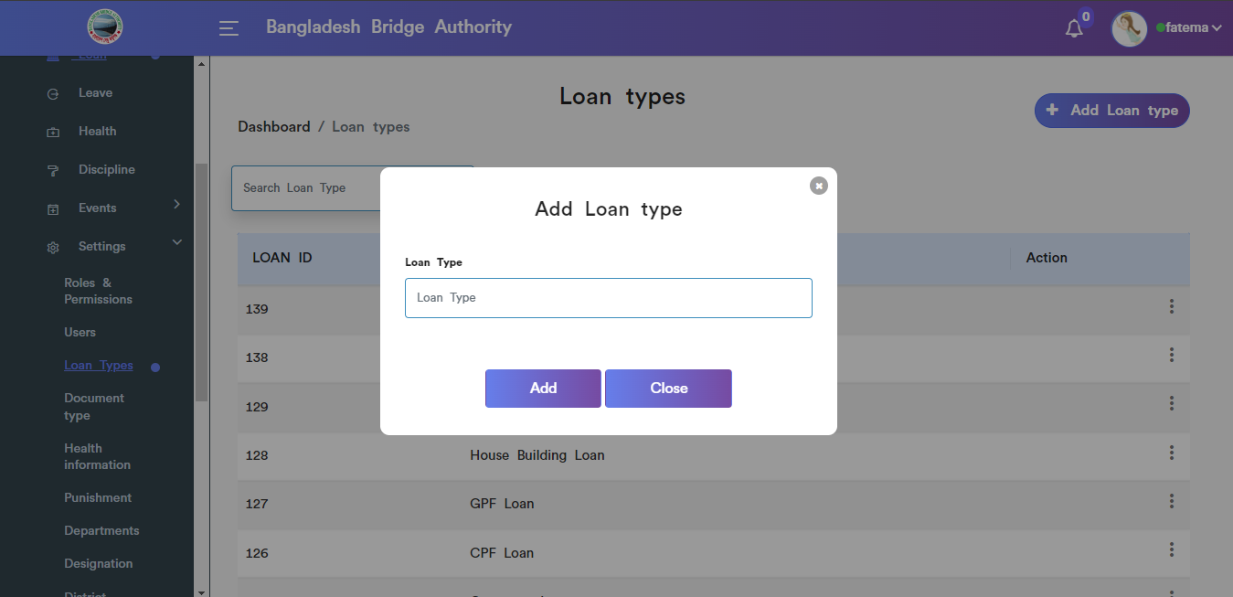

Figure: Add Loan type input field

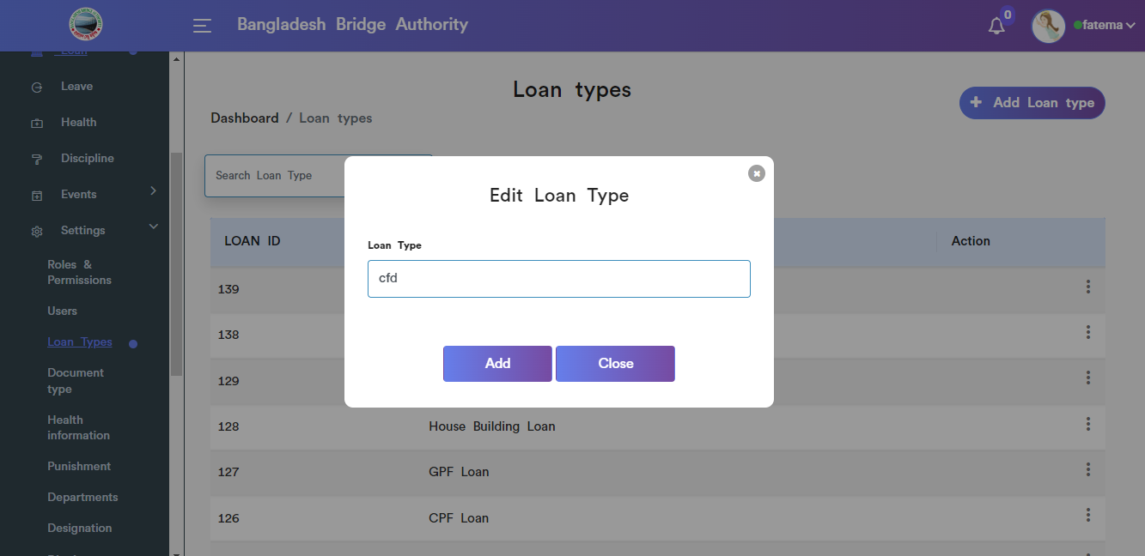

Figure: Edit loan type input field

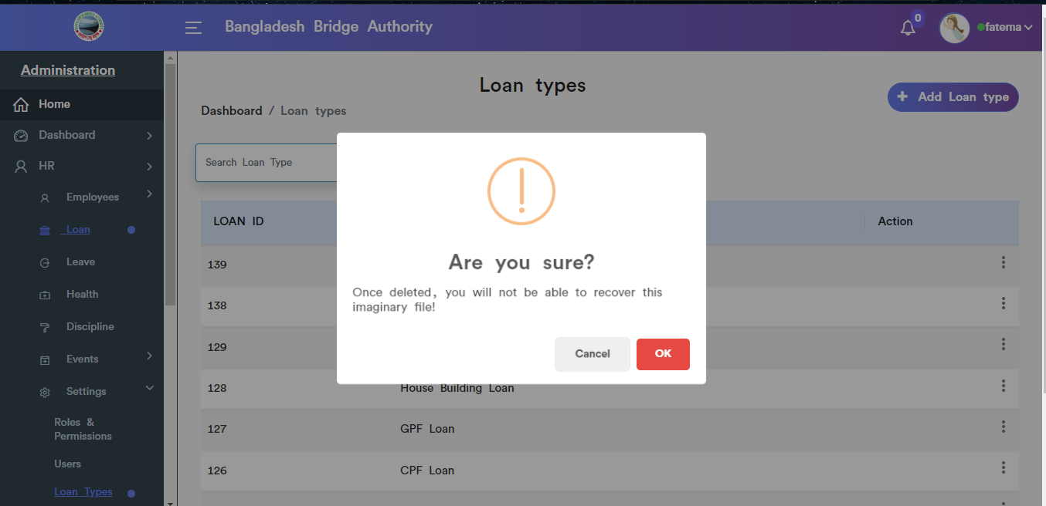

Figure: Delete Loan type pop-up modal.

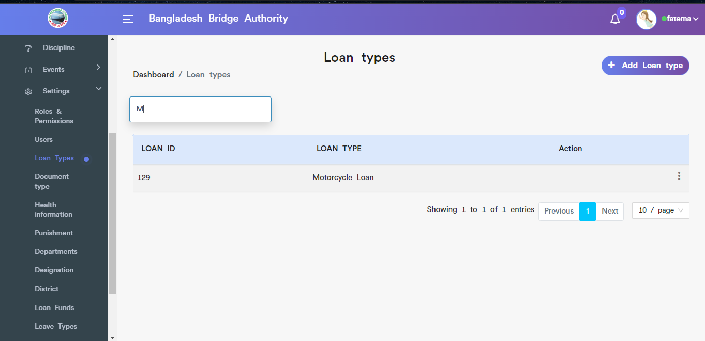

Figure: To see the specific loan type data Search it from the search input box.

1. **Document Type:** Clicking on **Administration > Human Resource > HR > Settings> Docment Types**.This page allow to add new document type ,view document type , Search, Edit & Delete.

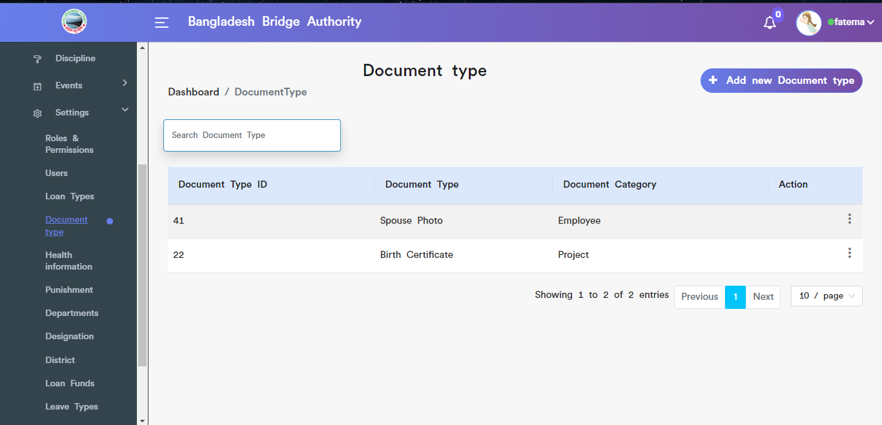

Figure: View document type

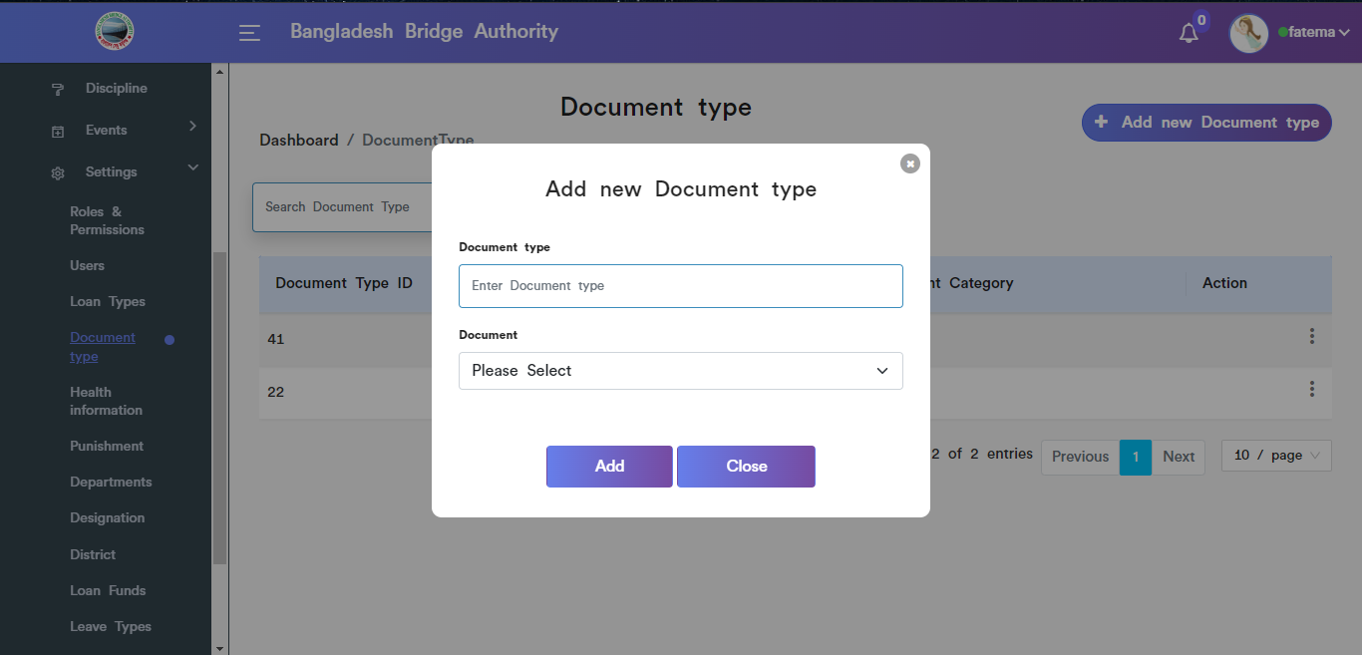

Figure: Add new document type input field

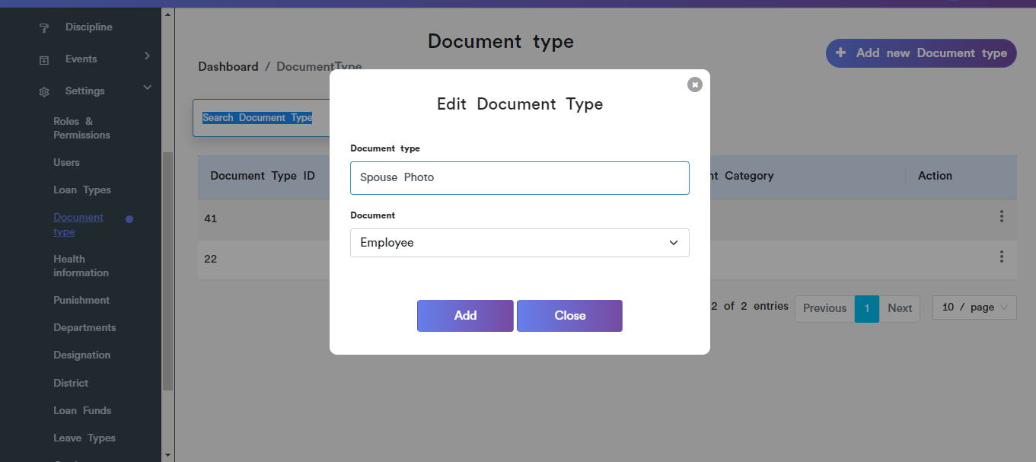

Figure: Document type edit input field

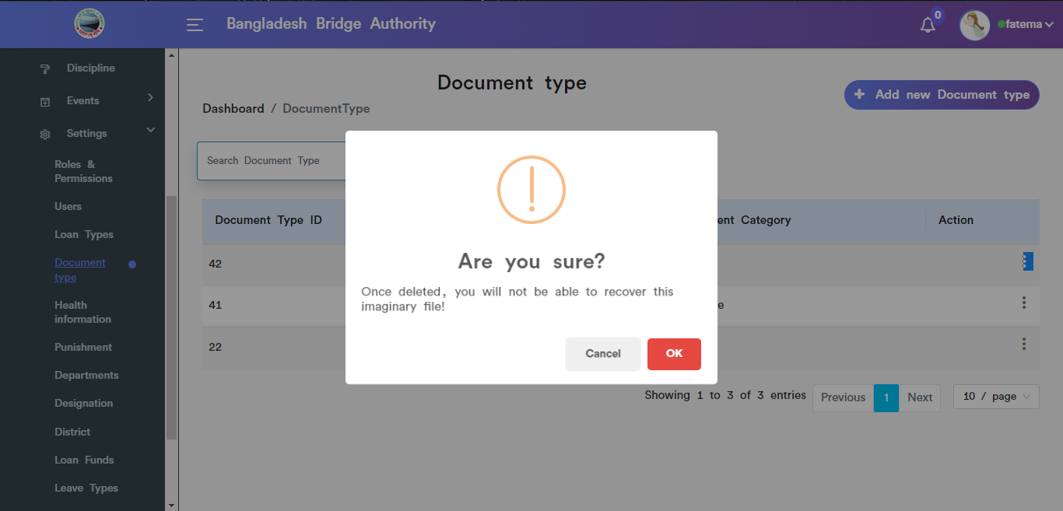

Figure: Document type delete pop-up modal.

1. **Health Information:** Clicking on **Administration > Human Resource > HR > Settings> Health Information**.This page allow to add new health information ,view health information , Search, Edit & Delete.

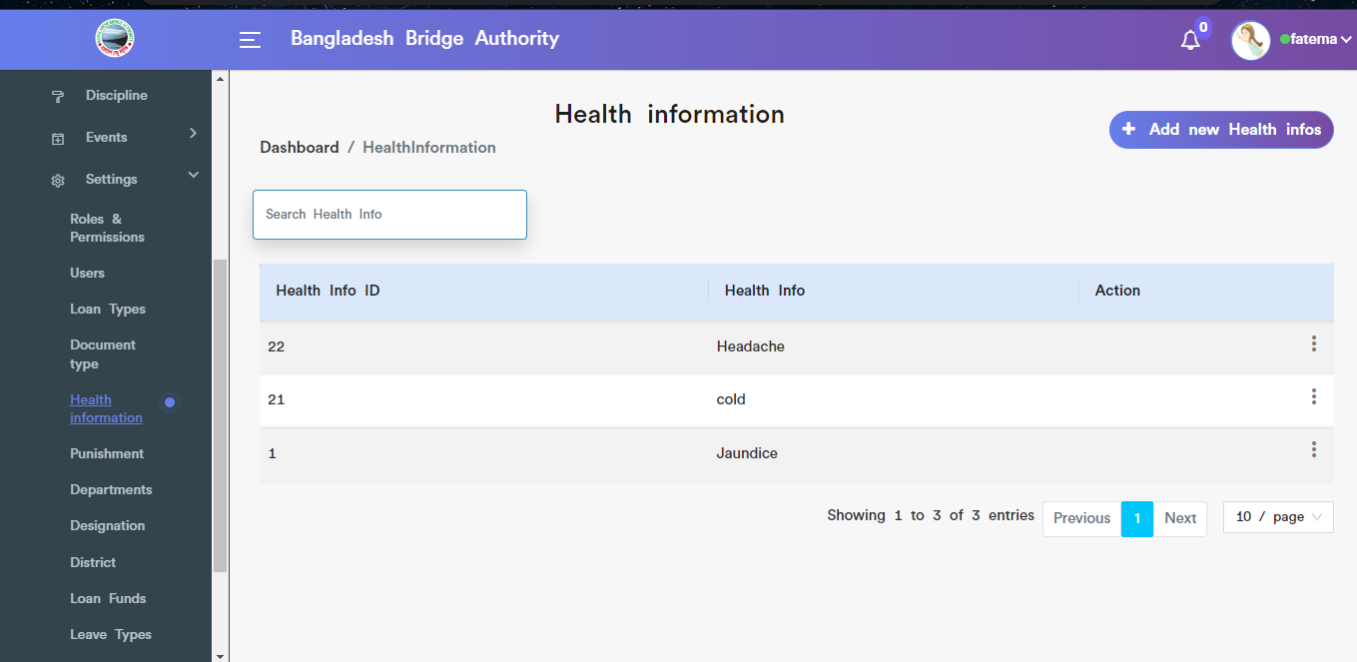

Figure:View of health information details.

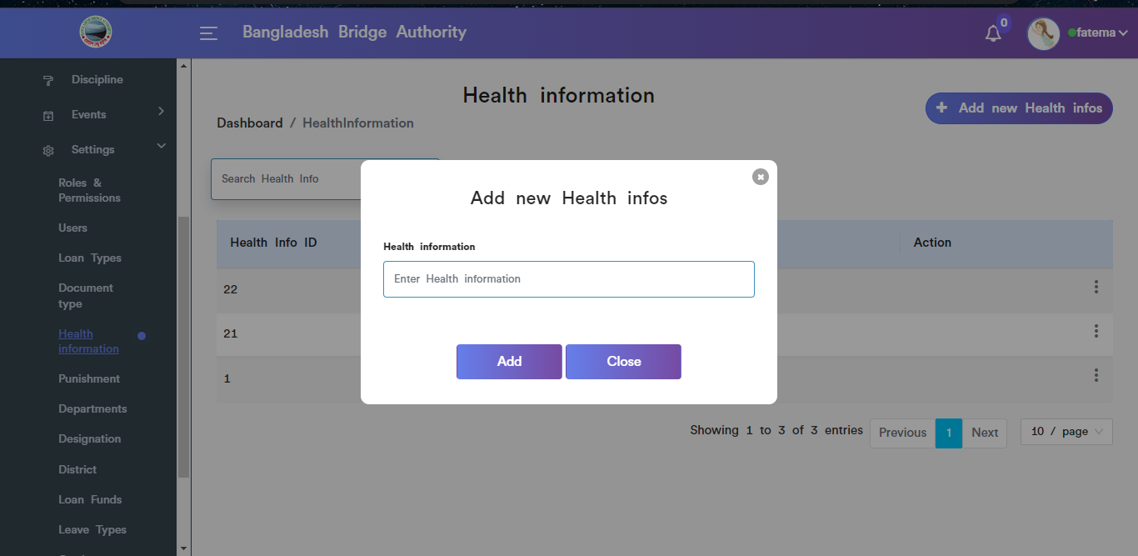

Figure:Add new health info input field.

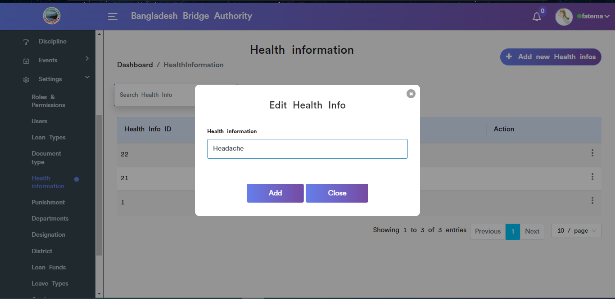

Figure: Edit health info input field.

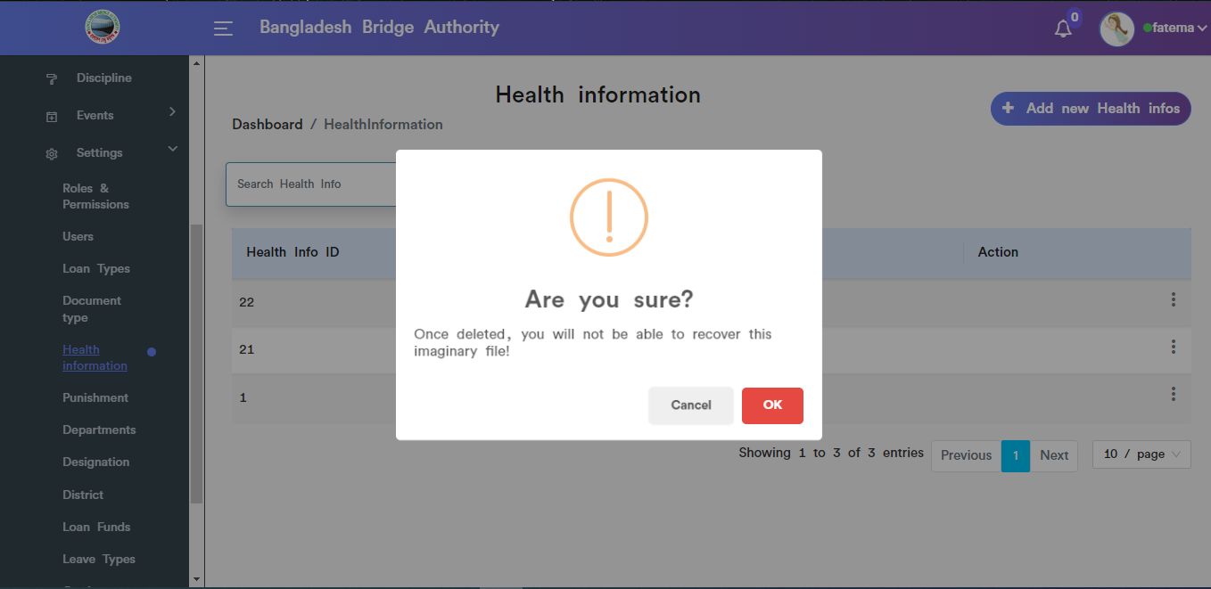

Figure: Health info deletes pop-up modal.

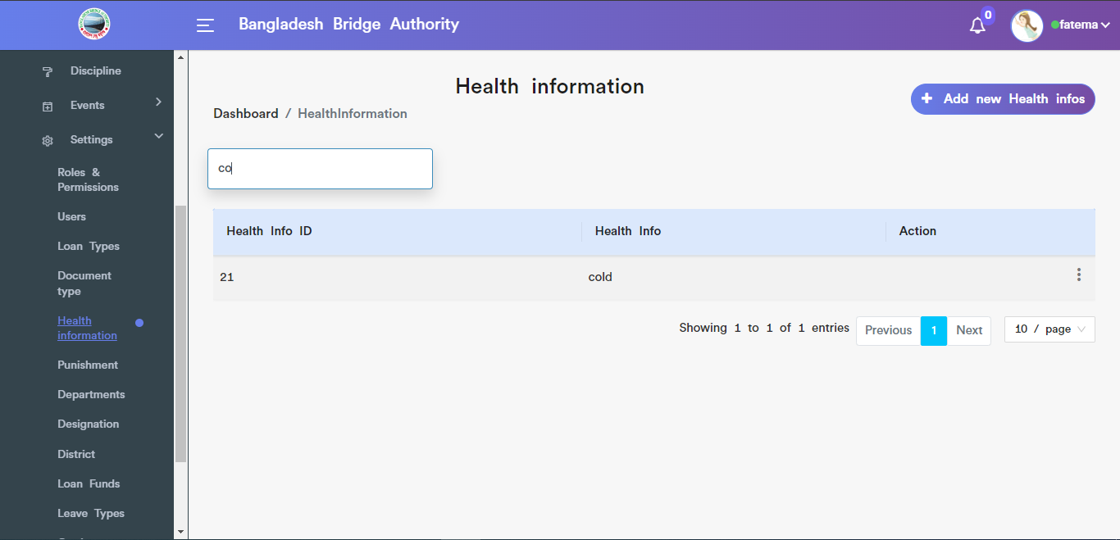

Figure: Health Information search functionality .

1. **Punishment:** Clicking on **Administration > Human Resource > HR > Settings>Punishment**.This page allow to add new punishment ,view of punishment , Search, Edit & Delete.

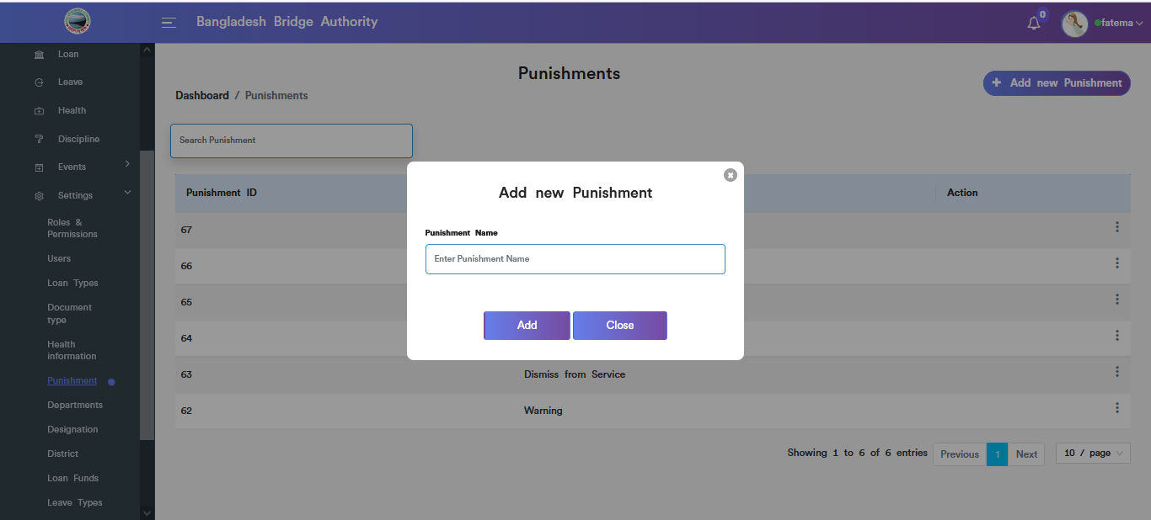

Figure:Add new punishment input field .

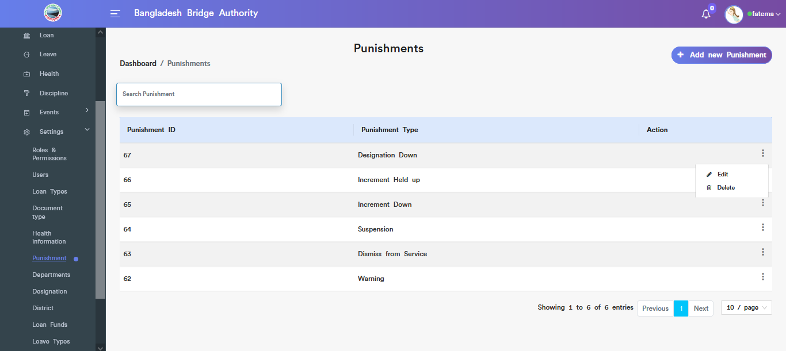

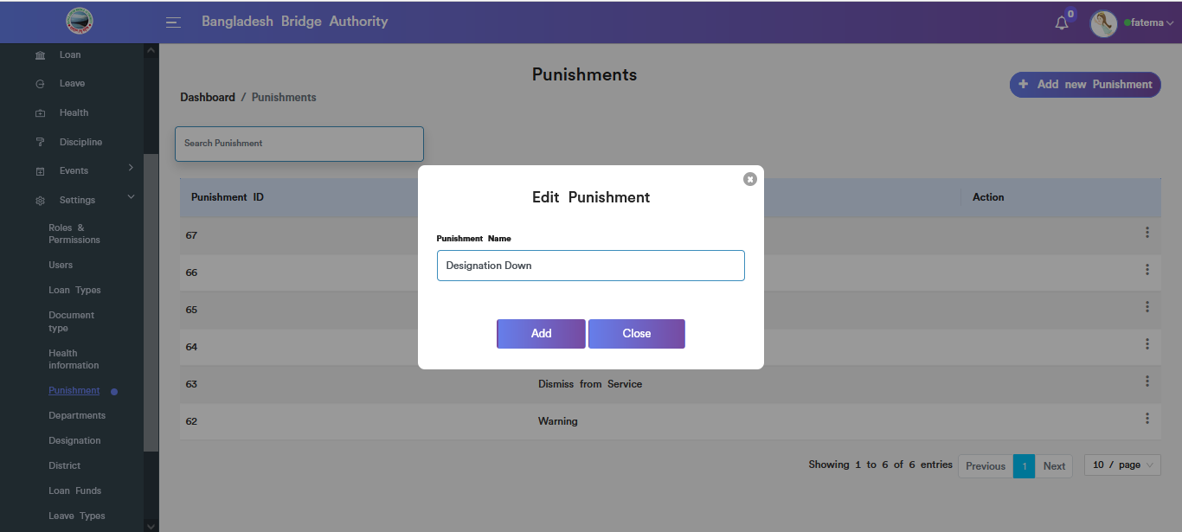

Figure: Punishment edit input field .

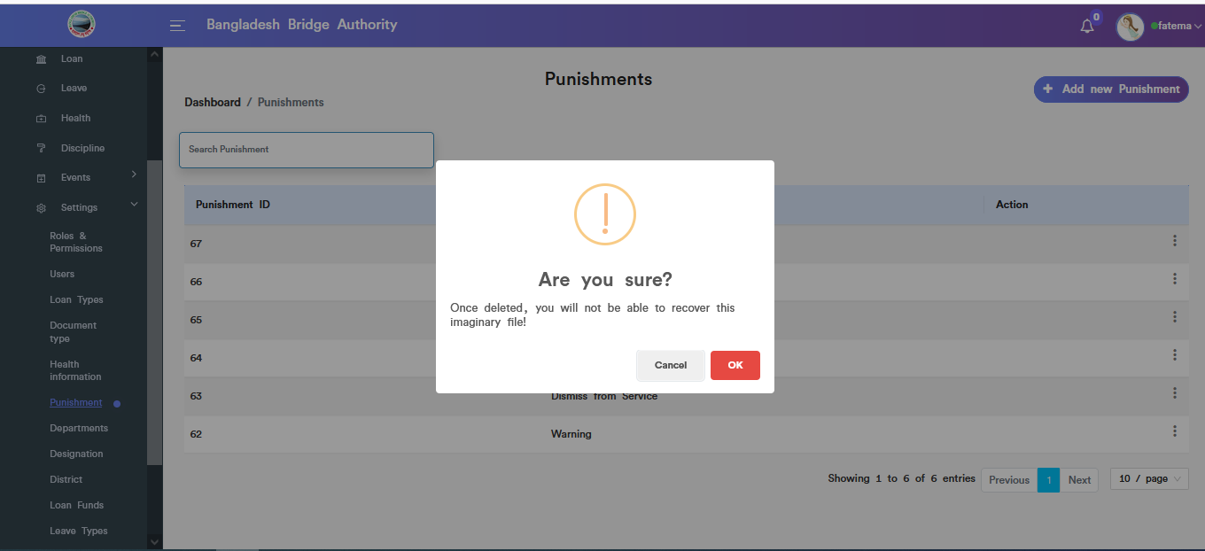

Figure: Punishment delete pop-up modal.

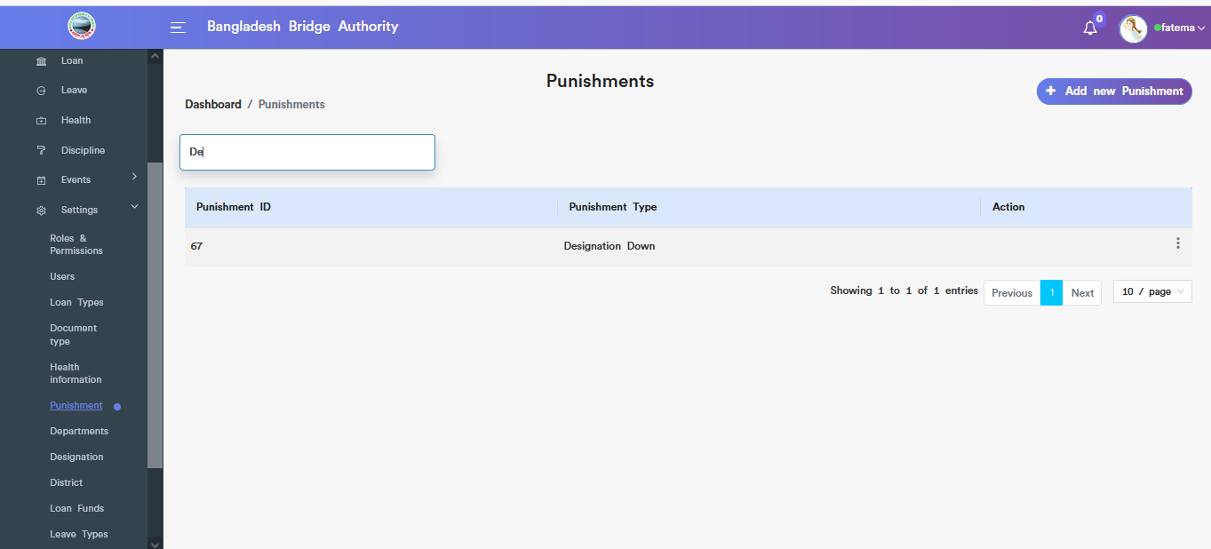

Figure: Punishment Search Option.

1. **Departments:** Clicking on **Administration > Human Resource > HR > Settings>Departments**.This sub-menu allow to add new Department ,view of Department , Search, Edit & Delete.

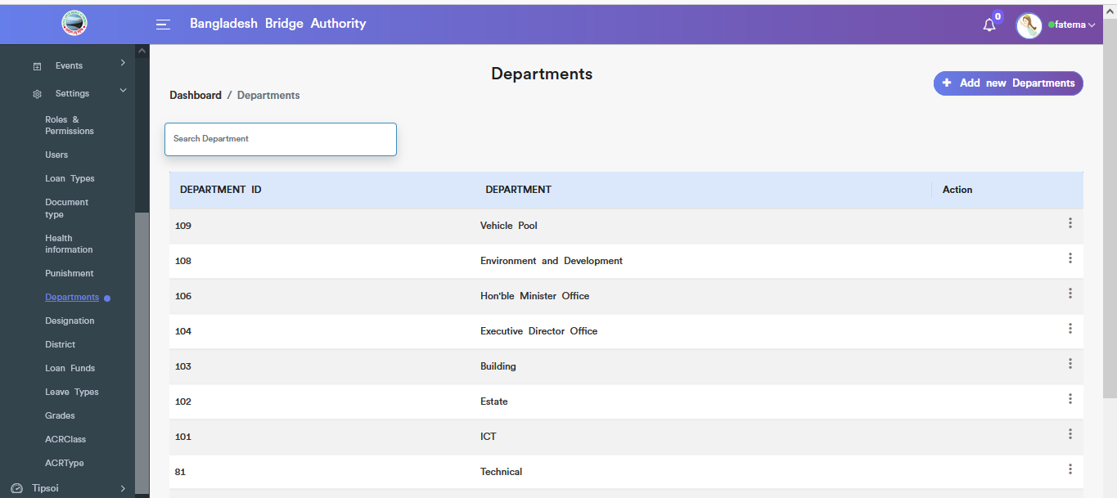

Figure: View of all departments.

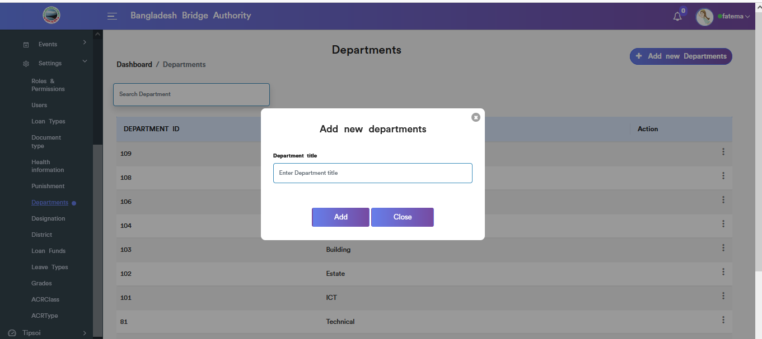

Figure: Add new department input field.

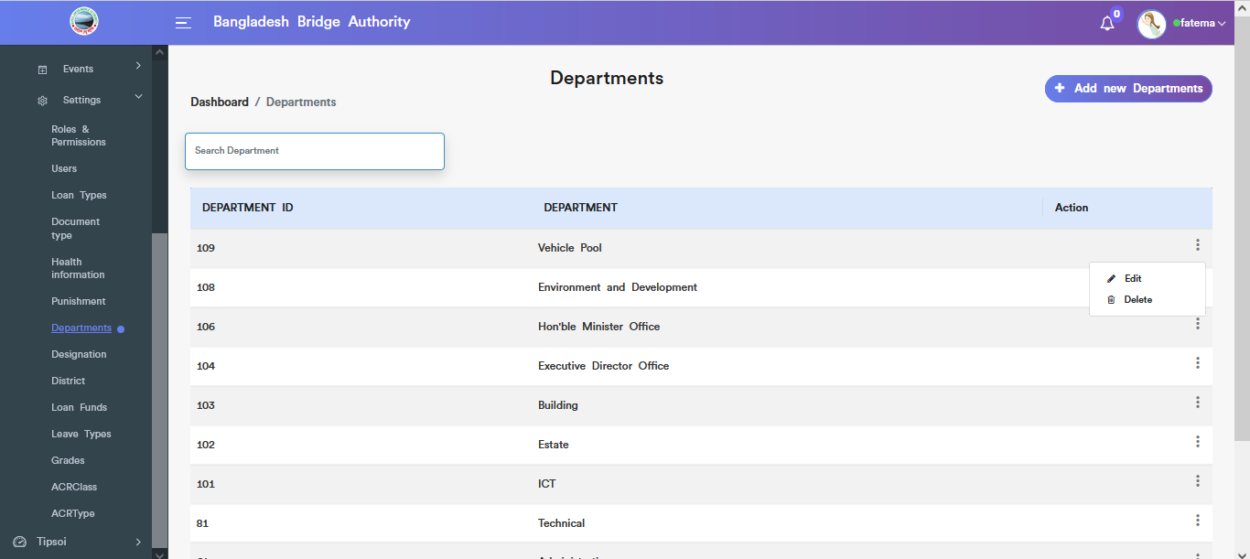

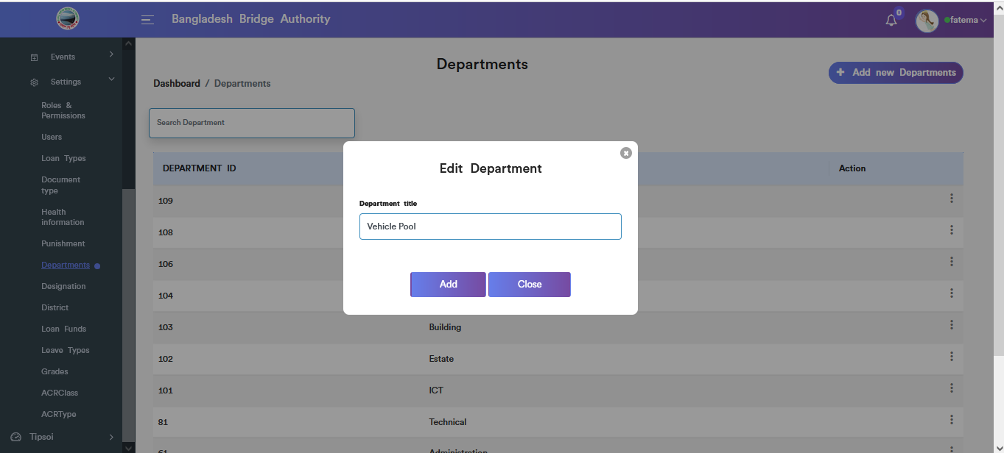

Figure: Department edit input field.

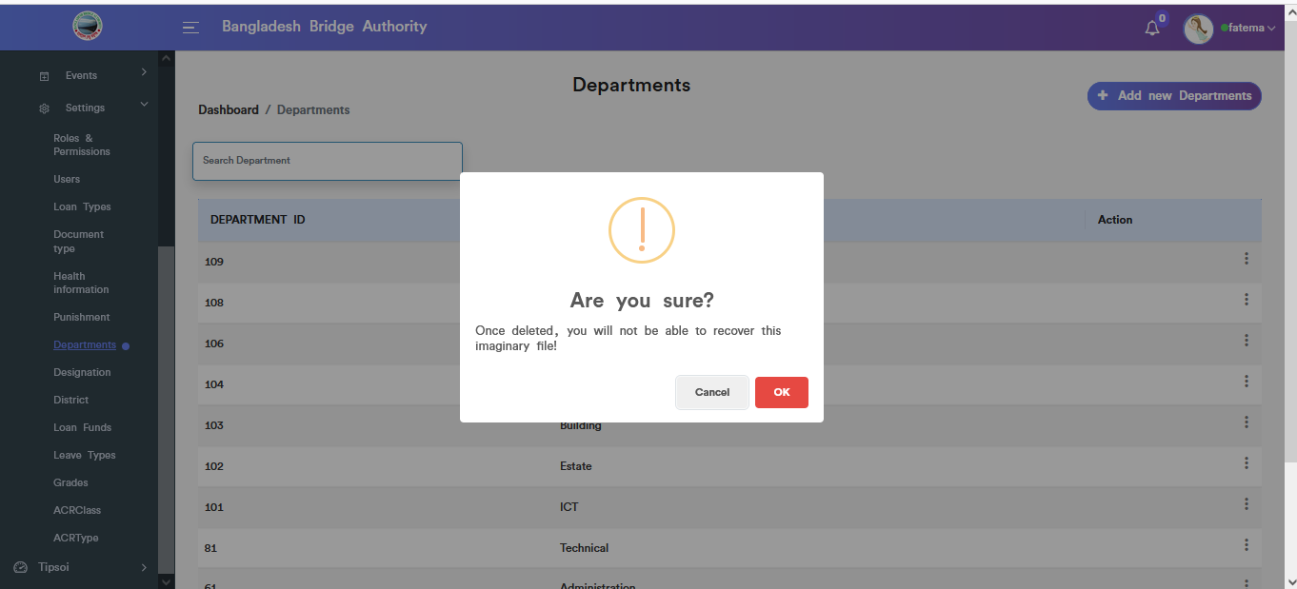

Figure: Department deletes input field.

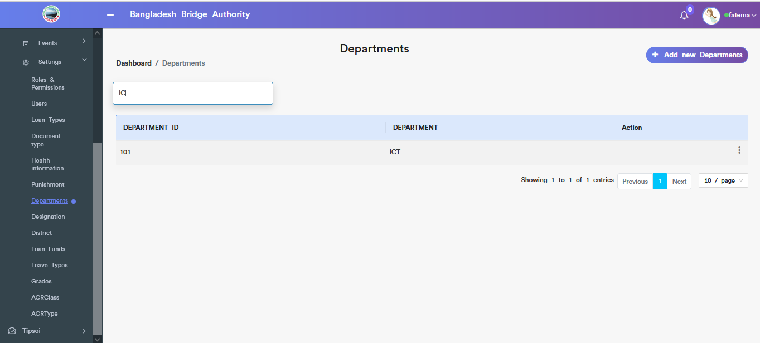

Figure: Department search functionality.

1. **Designation:** Clicking on **Administration > Human Resource > HR > Settings>Designation** .This sub-menu allow to add new Designation ,view of all designations , Search, Edit & Delete.

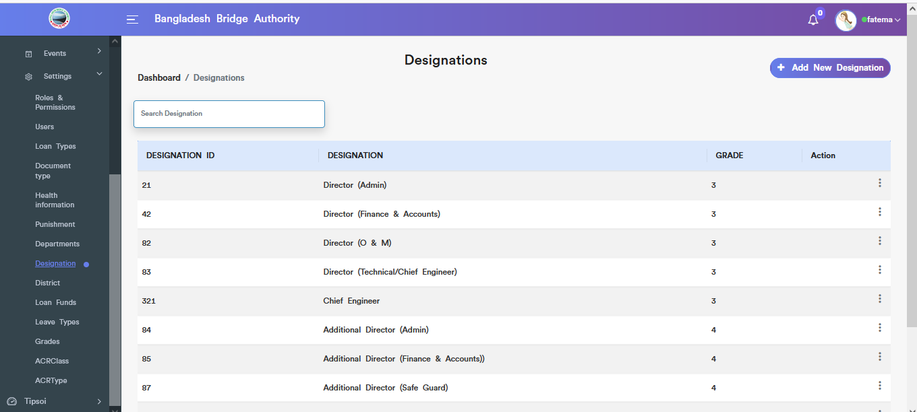

Figure: View details of designation.

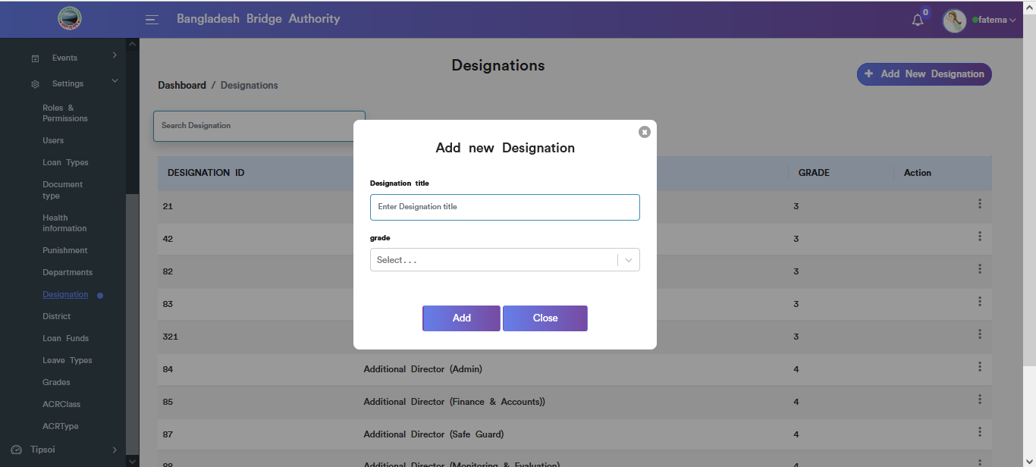

Figure: Add new designation input field.

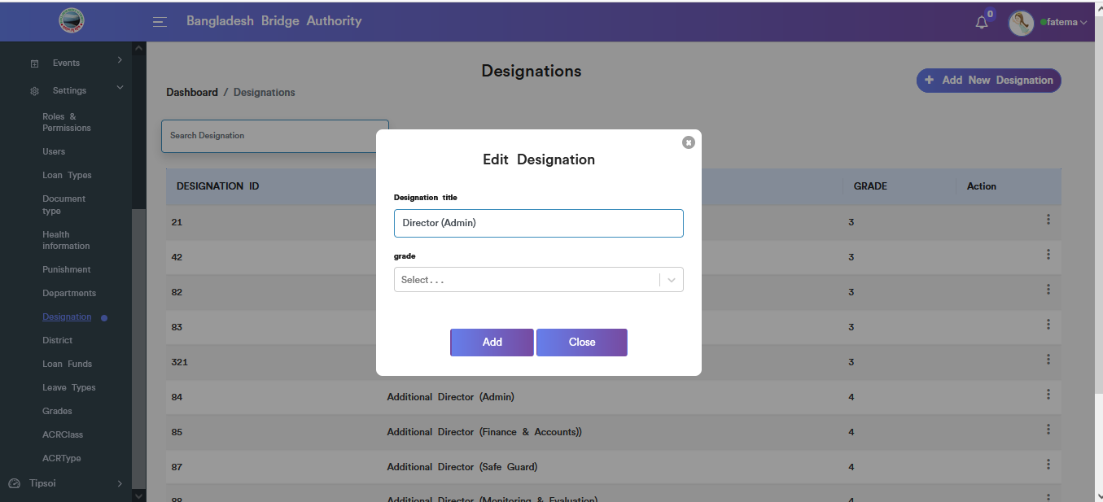

Figure: Designation edit input field.

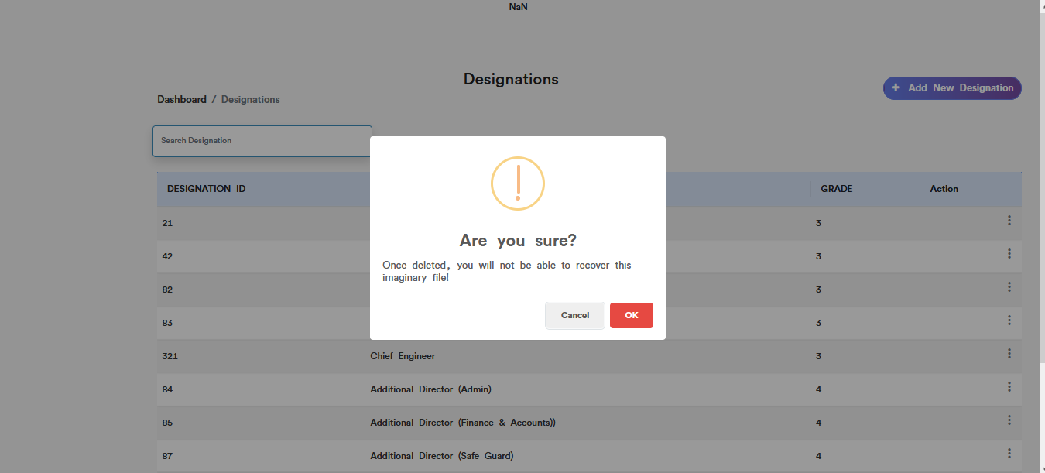

Figure: Designation deletes pop-up modal.

1. **District:** Clicking on **Administration > Human Resource > HR > Settings>District** .This sub-menu allows to add new district according to employees id ,view all districts , Search, Edit & Delete.

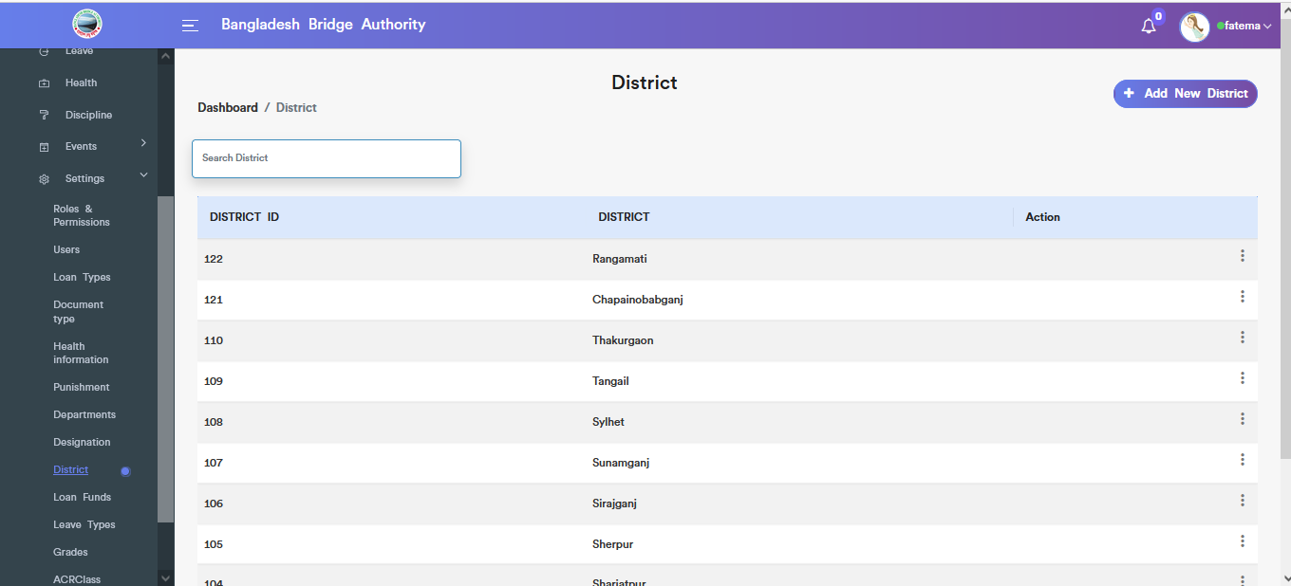

Figure: View all districts according to employees id.

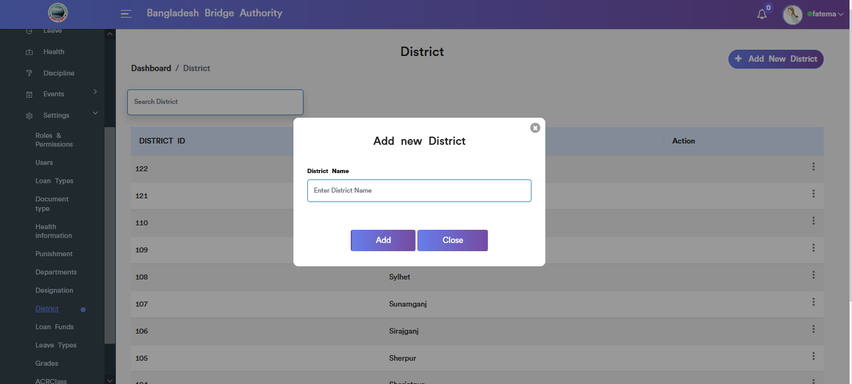

Figure: Add new district input field.

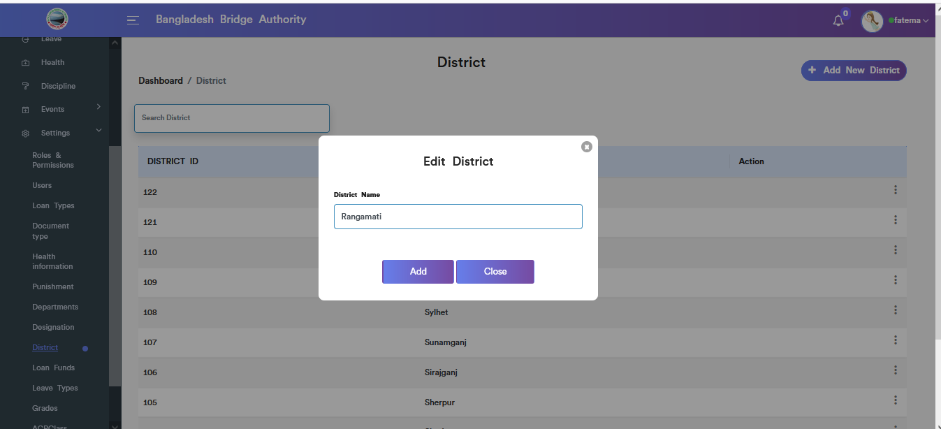

Figure: Edit district input field.

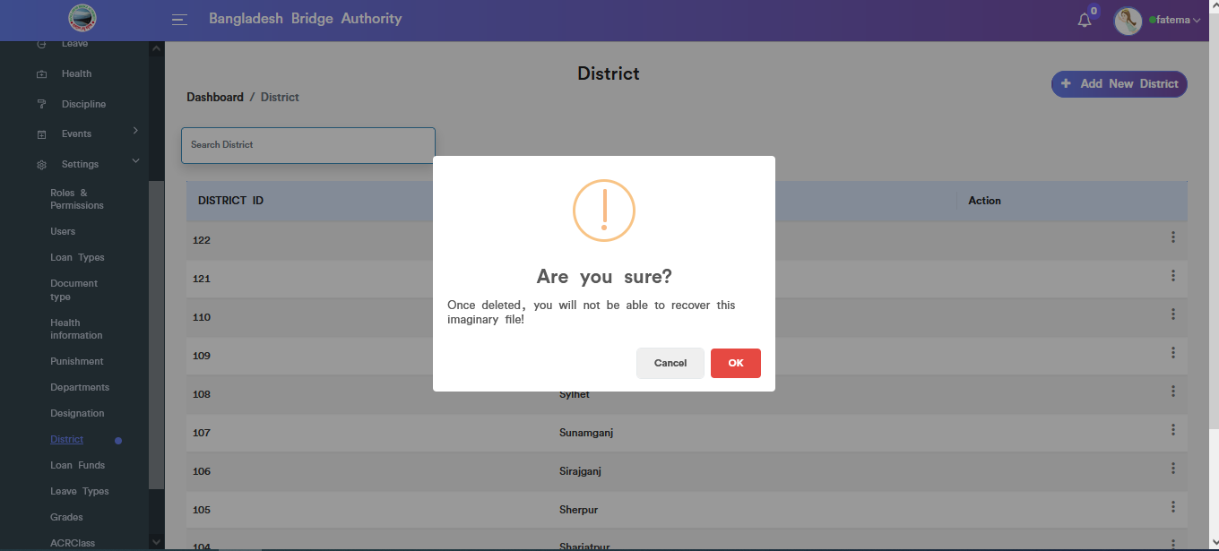

Figure: District deleted pop-up modal .

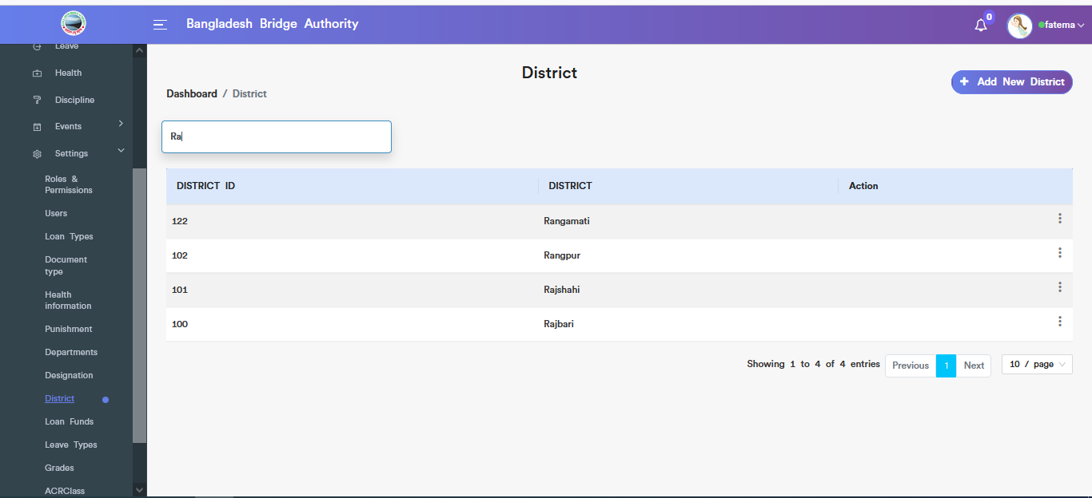

Figure: Get specific district using the search option field.

1. **Loan Funds:** Clicking on **Administration > Human Resource > HR > Settings>Loan funds** .This sub-menu allows to add new loan fund according to loan funds id ,view all loan funds , Search, Edit & Delete.

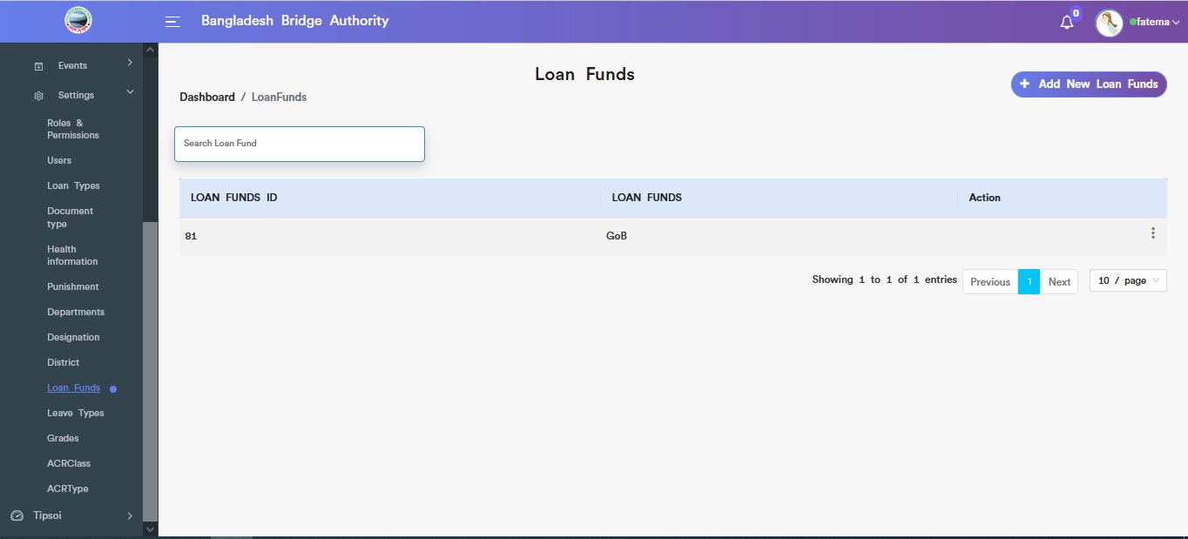

Figure: View of all loan funds.

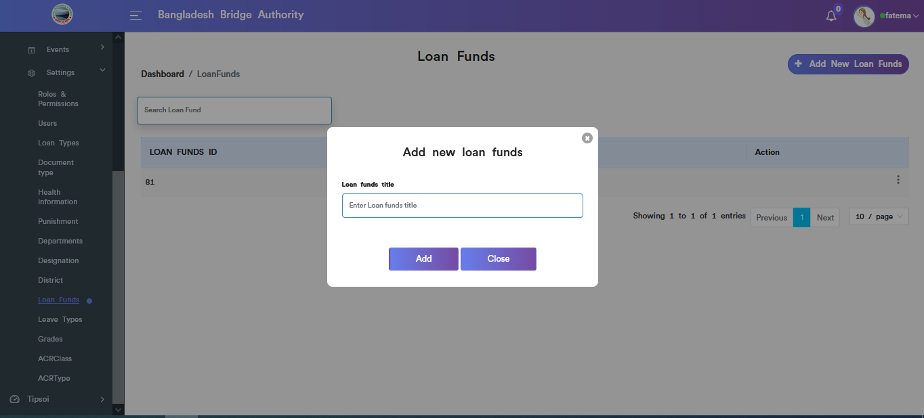

Figure: Add new loan funds input field.

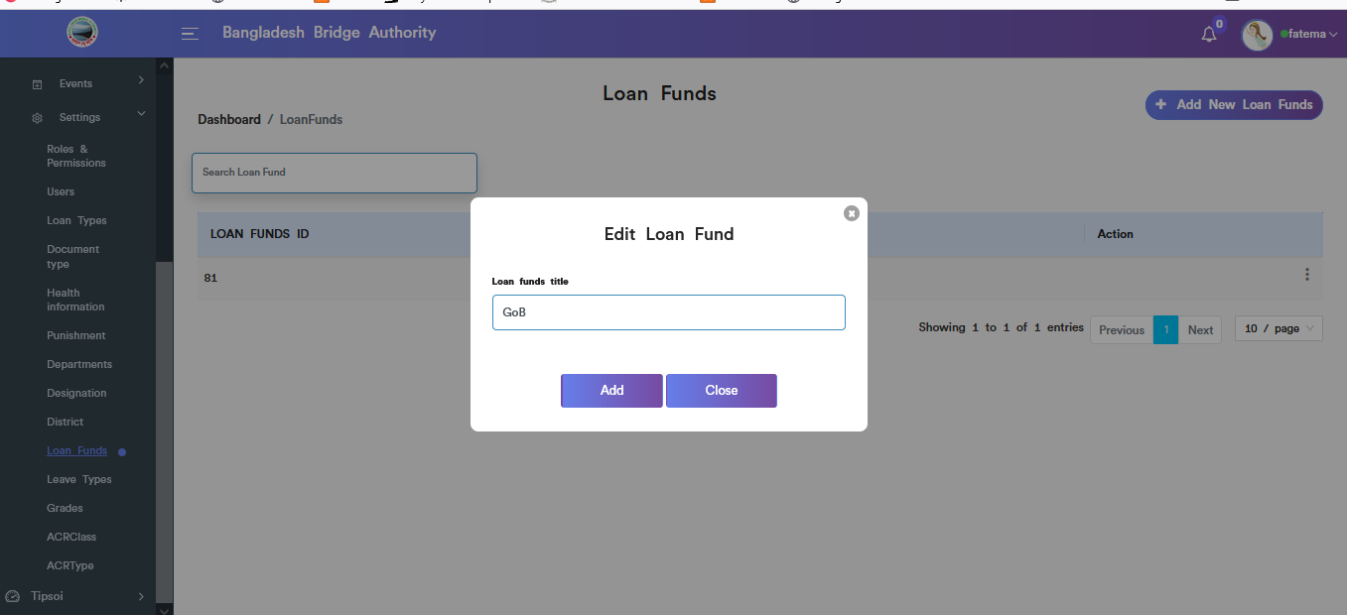

Figure: loan funds edit input field.

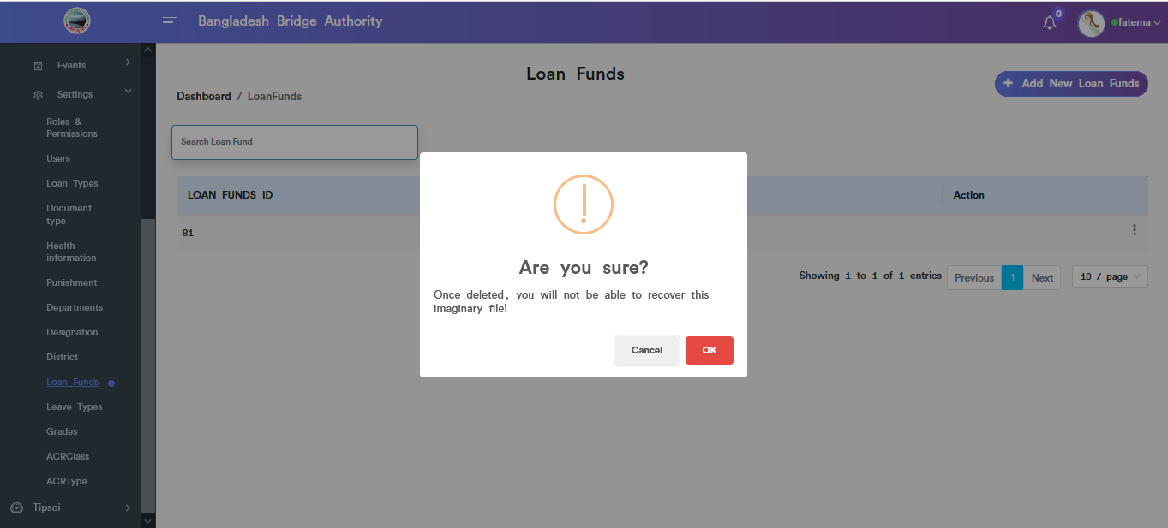

Figure: loan funds data deleted functionality.

1. **Leaves types:** Clicking on **Administration > Human Resource > HR > Settings>Leaves types** .This sub-menu allows to add new leave according to leave id ,view all leaves , Search, Edit & Delete.

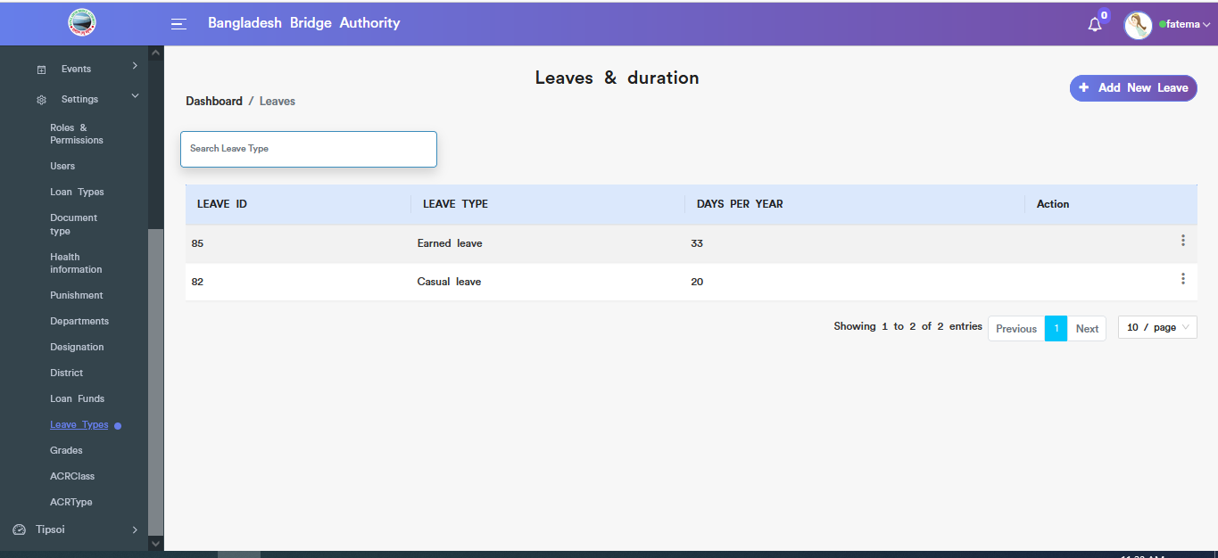

Figure: View all leaves information.

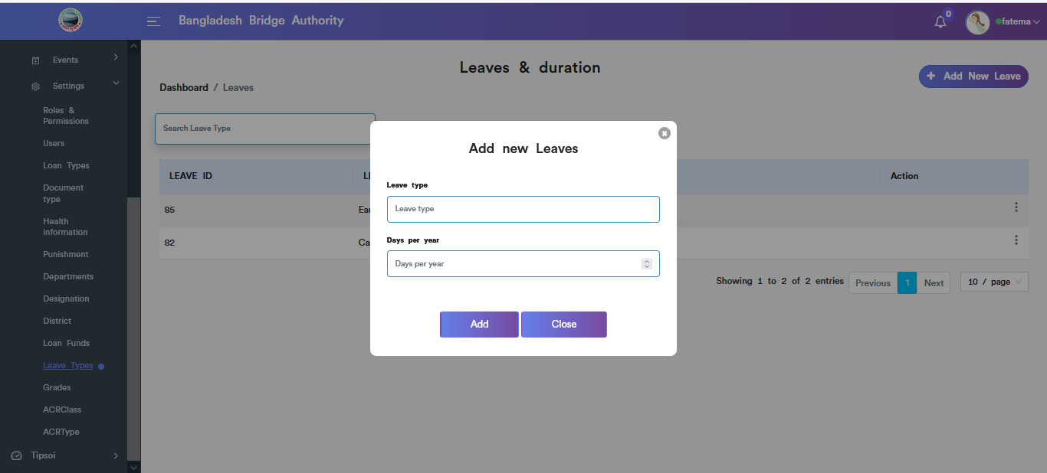

Figure: Add new Leaves input field.

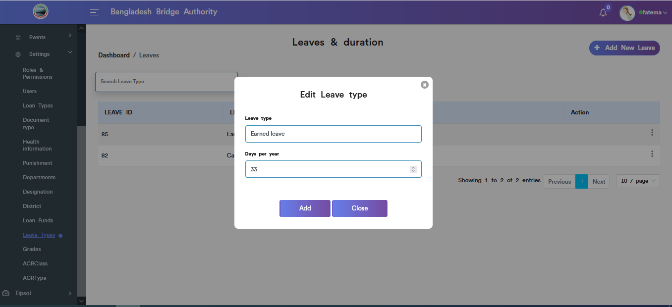

Figure: Leave update input field.

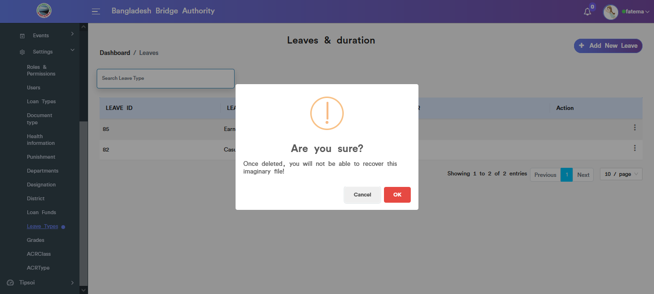

Figure: Leave data deleted functionality

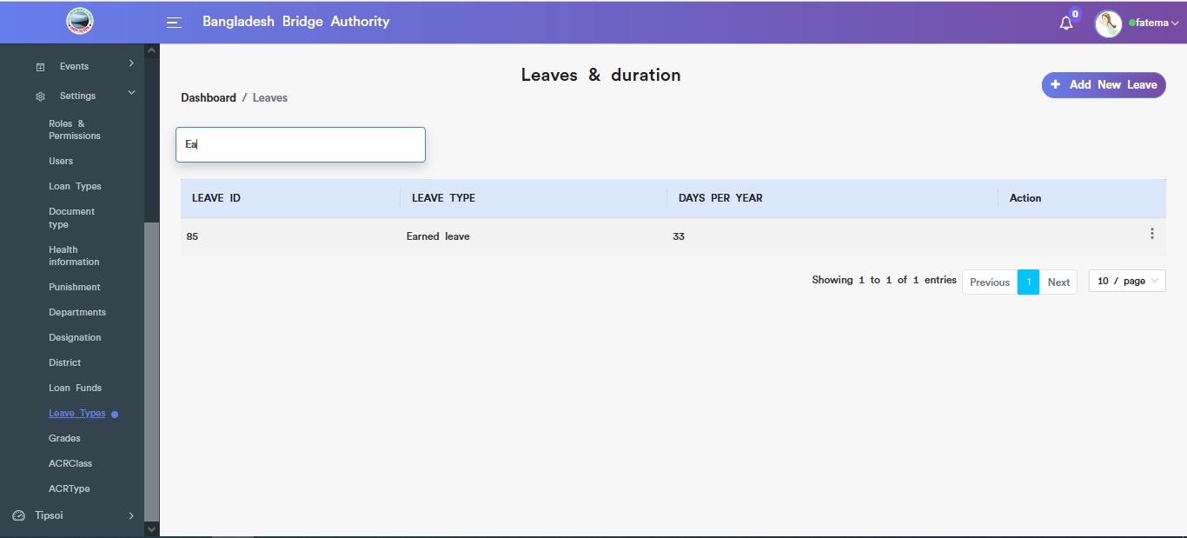

Figure: Leave Search functionality.

1. **Grades:** Clicking on **Administration > Human Resource > HR > Settings>Grades** .This sub-menu allows to add new grade ,view all grades , Search, Edit & Delete.

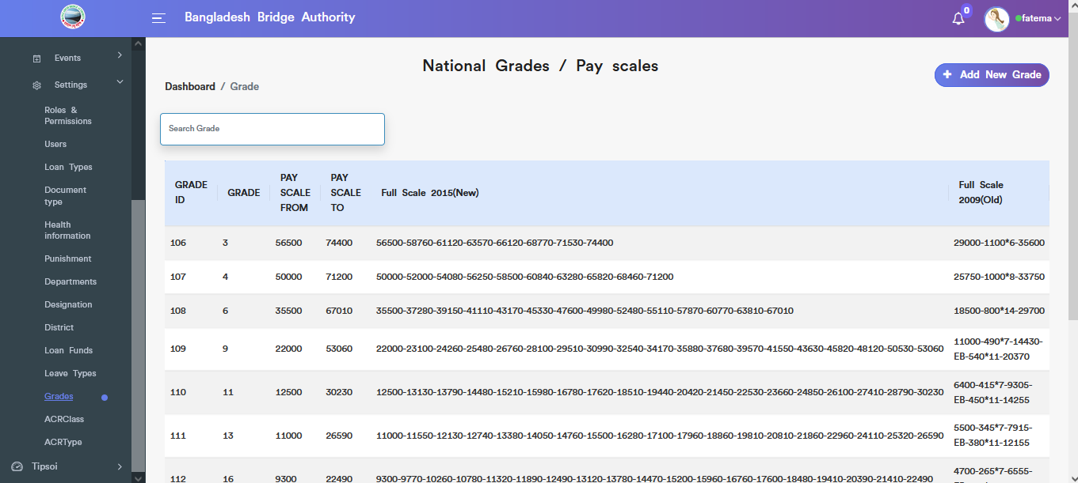

Figure: View of grades table.

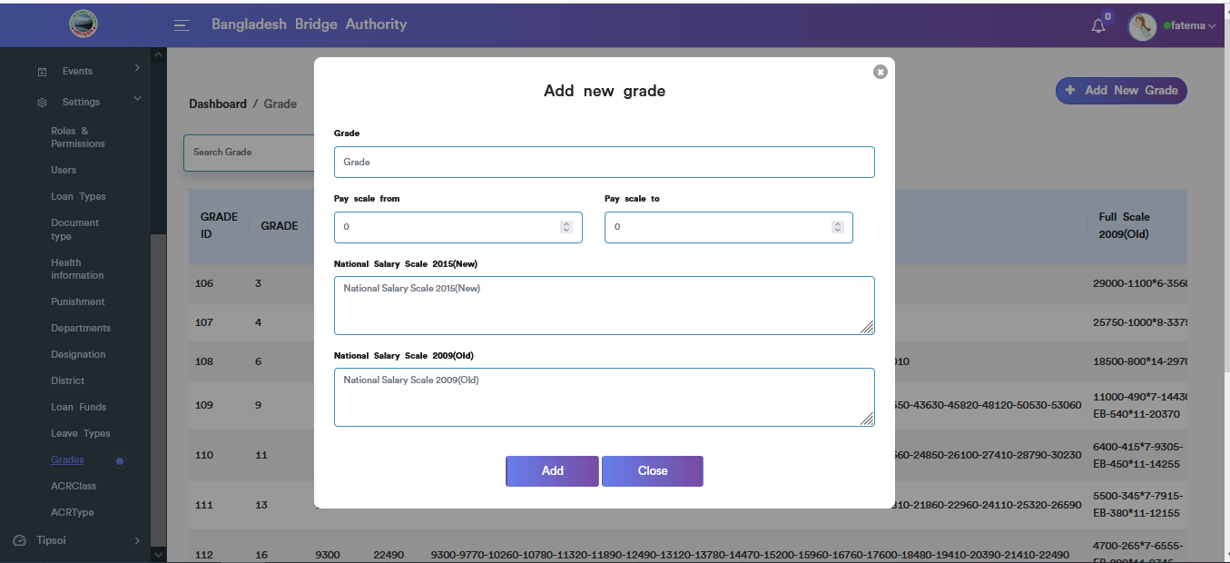

Figure: Add new grade input field.

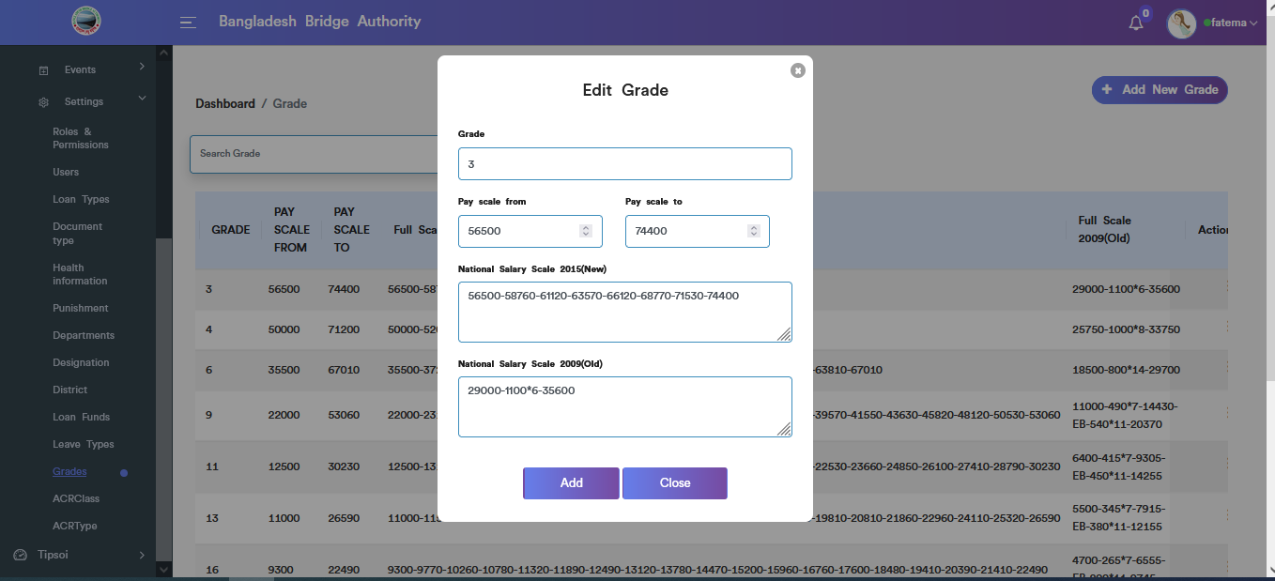

Figure: Grade Edit input field.

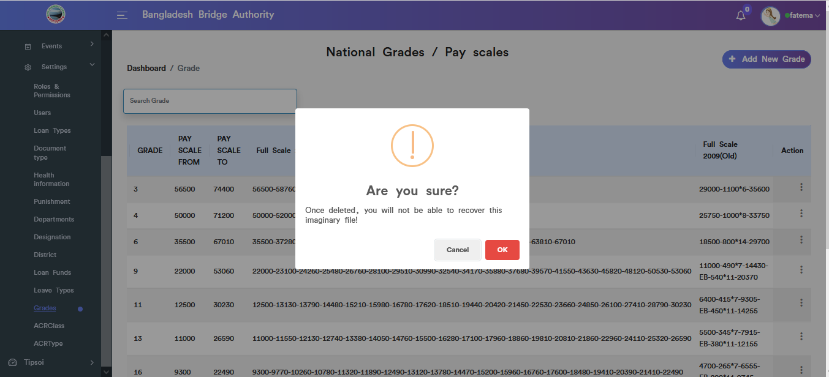

Figure: Grade data deleted functionality .

1. **ACRClass:** Clicking on **Administration > Human Resource > HR > Settings>ACRClass** .This sub-menu allows to add new ACRClass ,view ACRClass info, Search, Edit & Delete.

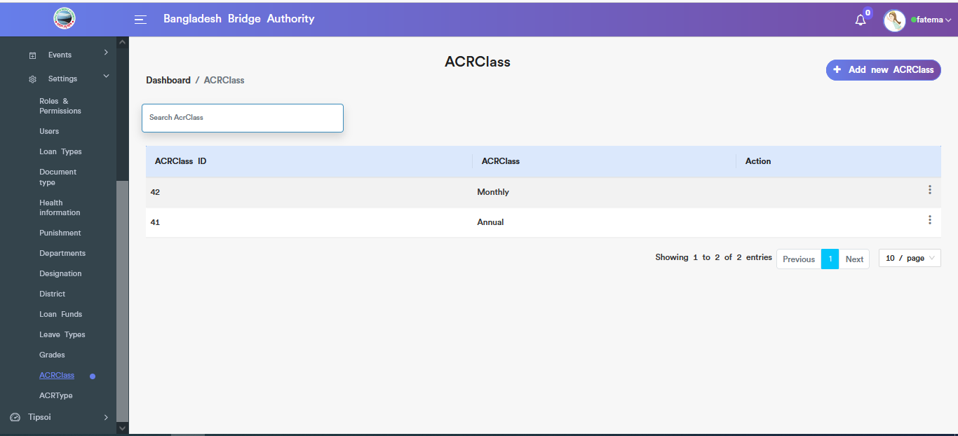

Figure: View ACRClass info.

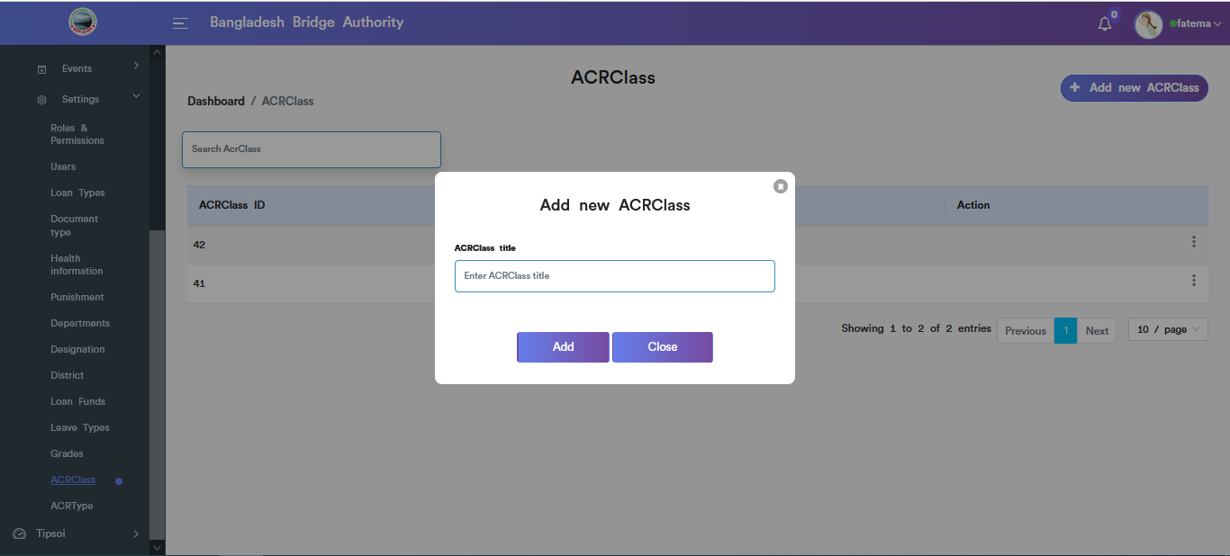

Figure: Add new ACRClass input field.

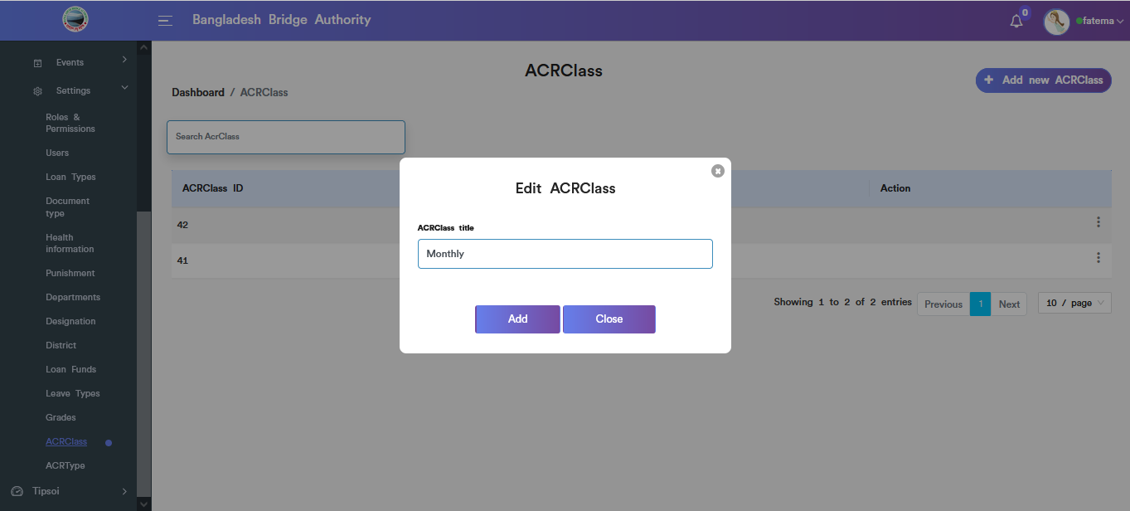

Figure: ACRClass Edit input field.

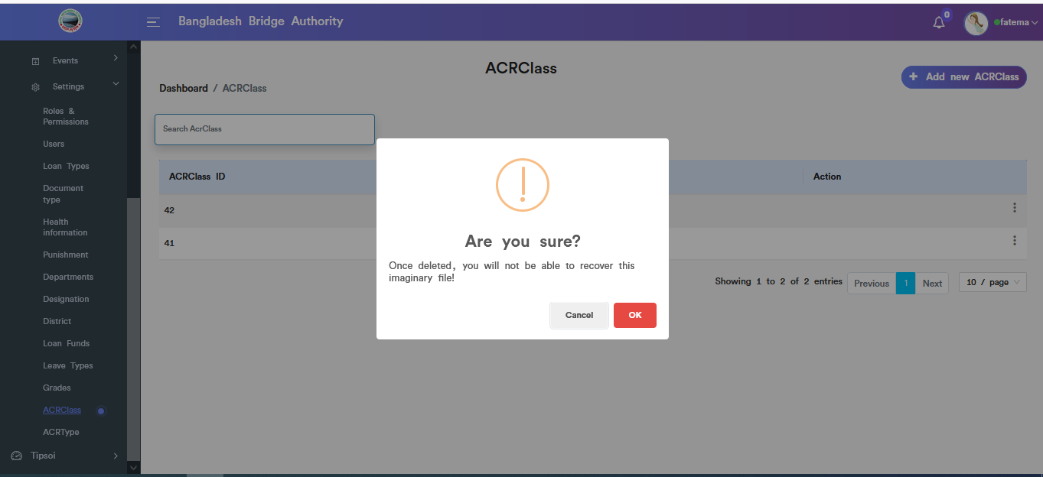

Figure: ACRClass data deleted functionality .

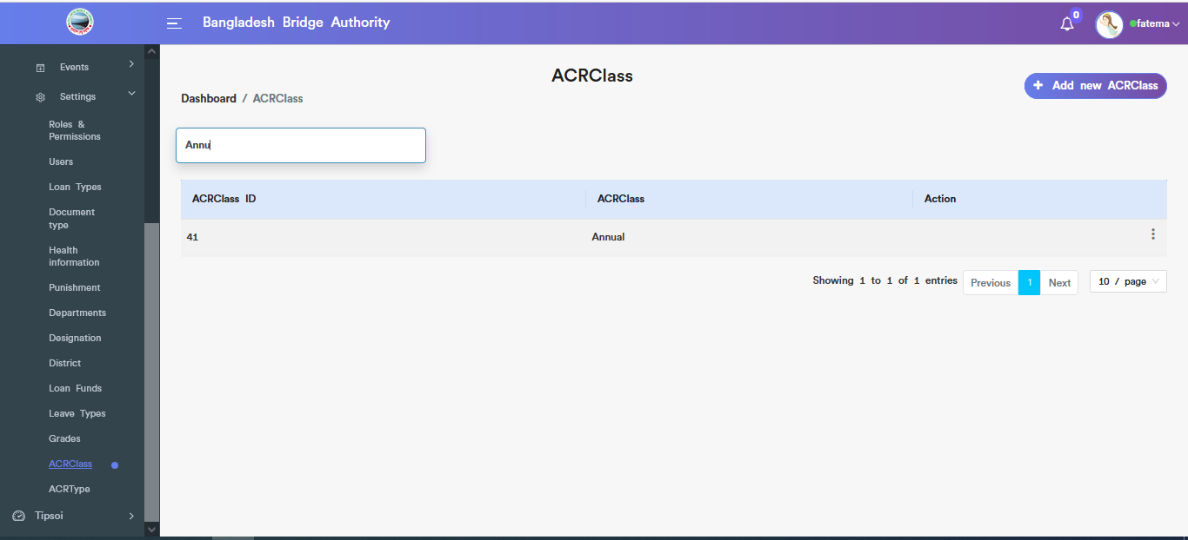

Figure: Search specific data from ACRClass table .

1. **ACRType:** Clicking on **Administration > Human Resource > HR > Settings>ACRType** .This sub-menu allows to add new ACRType ,view ACRType info, Search, Edit & Delete.

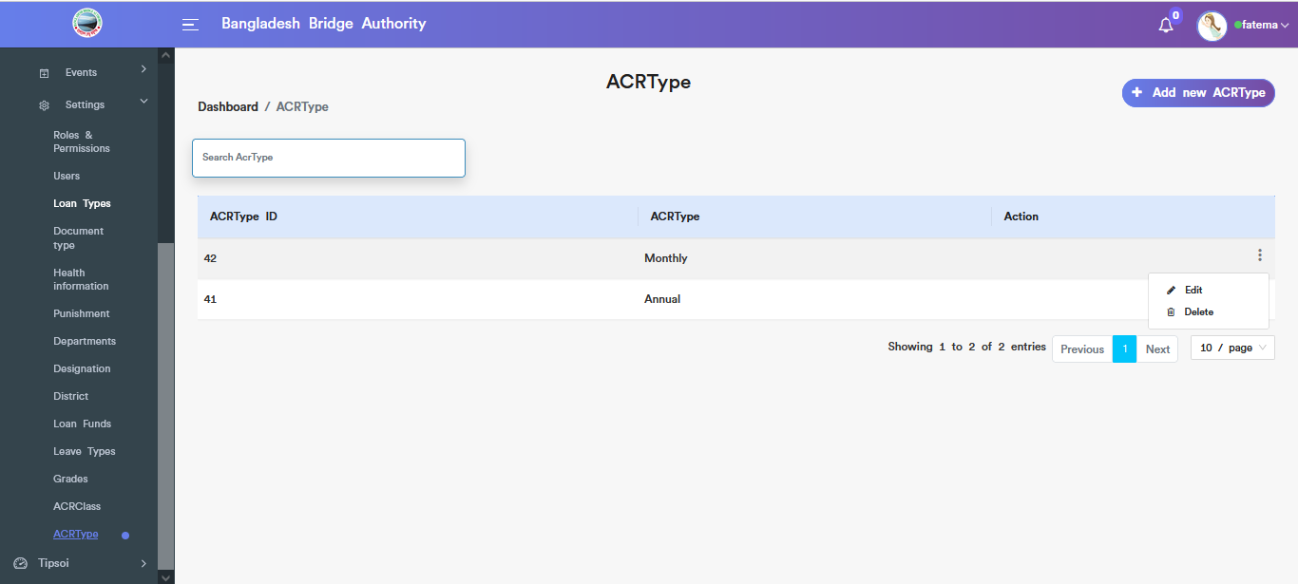

Figure:View ACRType info .

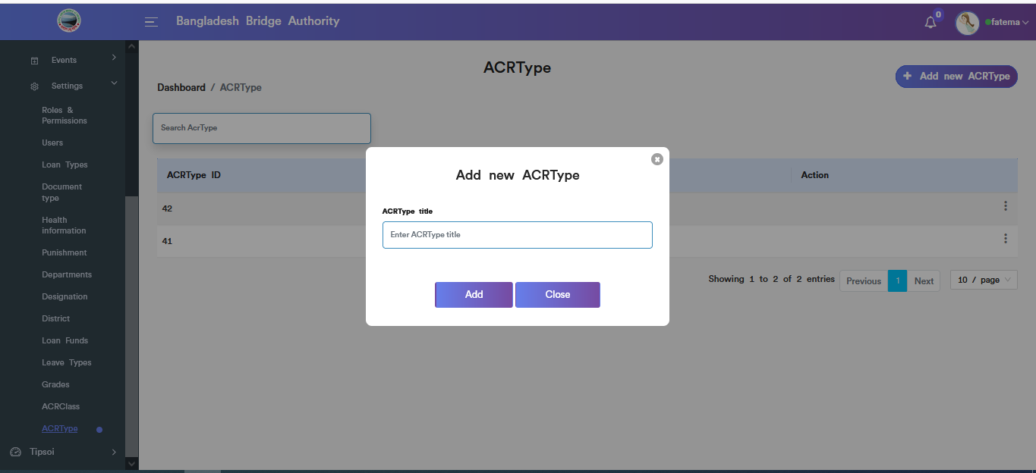

Figure:Add new ACRType input field .

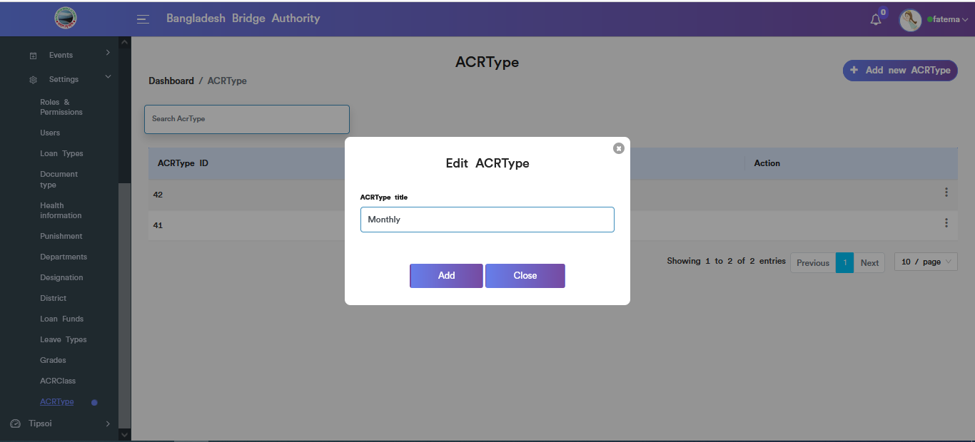

Figure: ACRType edit input field .

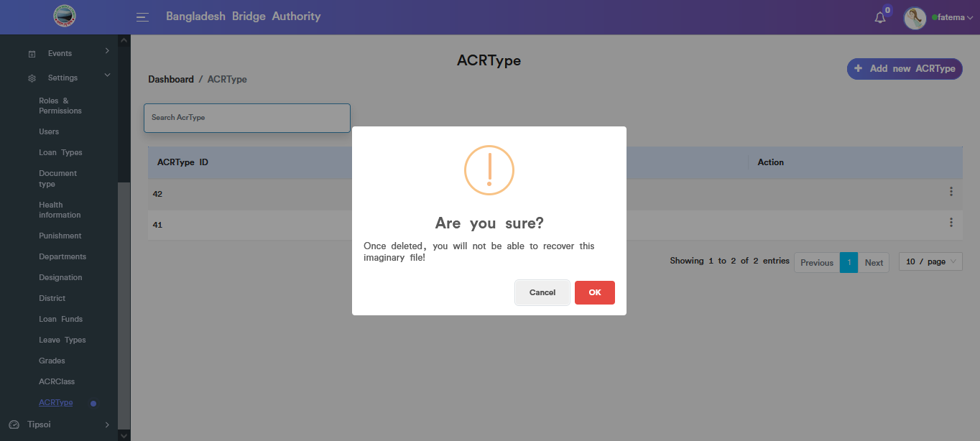

Figure: ACRType data deleted functionality

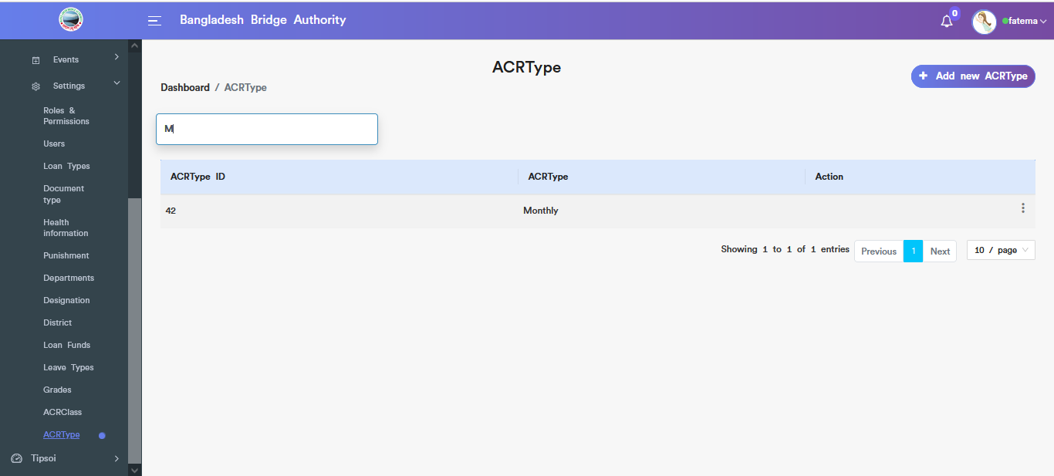

Figure:Get the specific ACRType data using search option

.

**Tipsoi Menus Overview**

**Tipsoi:** Clicking on **Administration > Human Resource > Tipsoi > Dashboard** .In the right side of the dashboard,there are four segments to count Total Employees ,Today Present ,Today Late ,Today Absent.

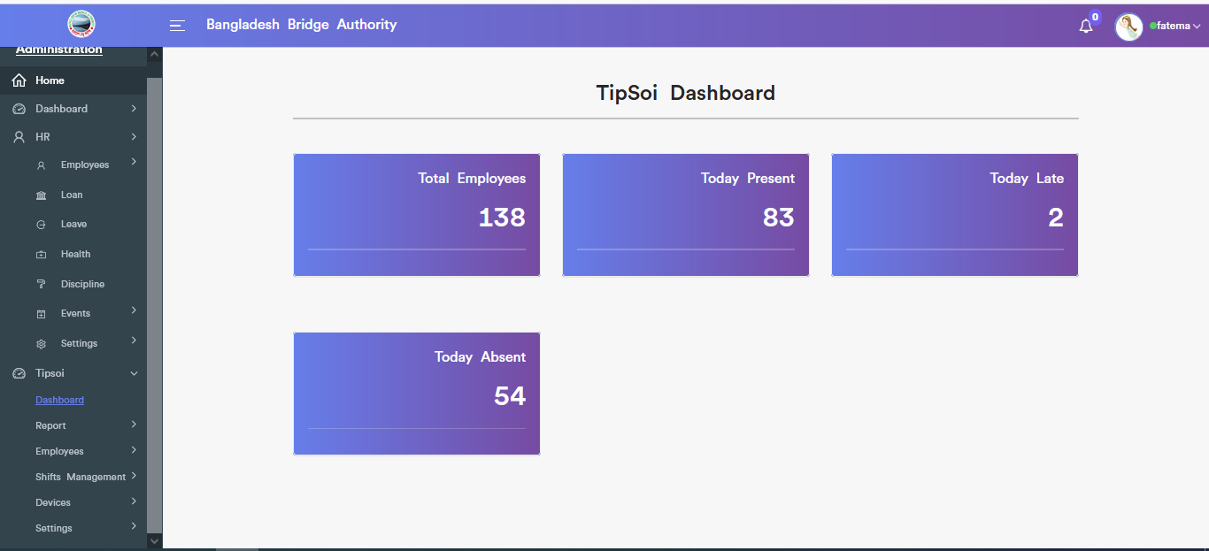

Figure: Figure: Dashboard of Tipsoi

**Overview of Report menu**

**Department Report:** Clicking on **Administration > Human Resource > Tipsoi > Report>Department Report** .This sub-menu shows the daily department report & allows to search to find specific attendance. Also, this sub-menu provides download daily department report file as excel.

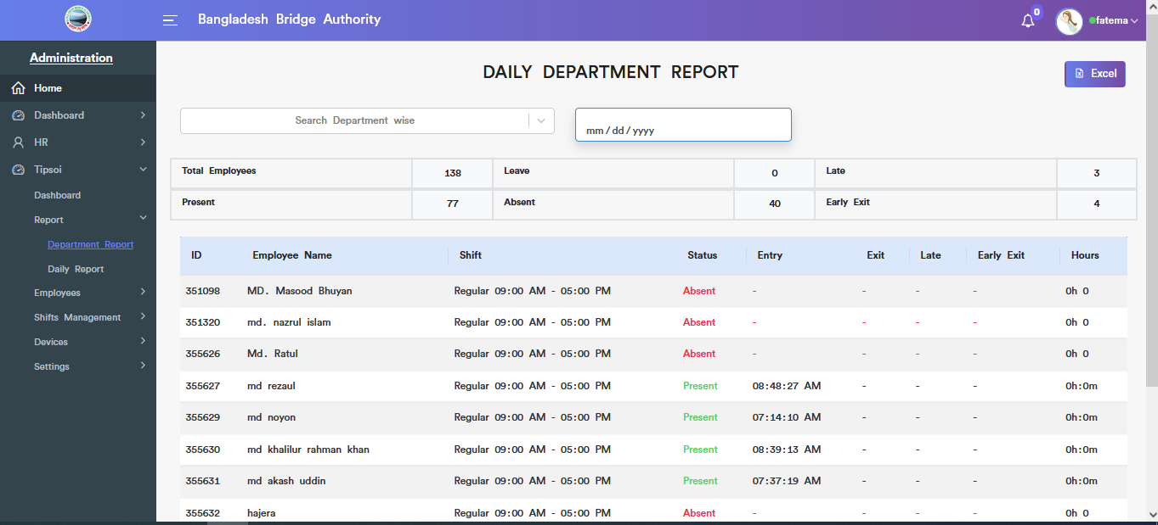

Figure : View Daily Department Report

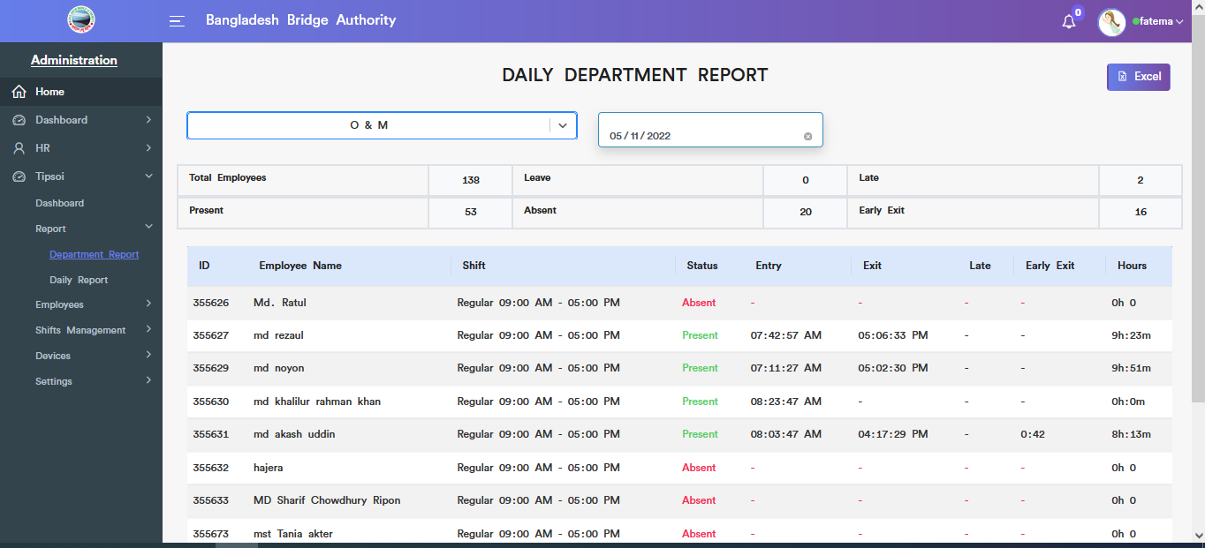

Figure : Daily Department Report Search functionality

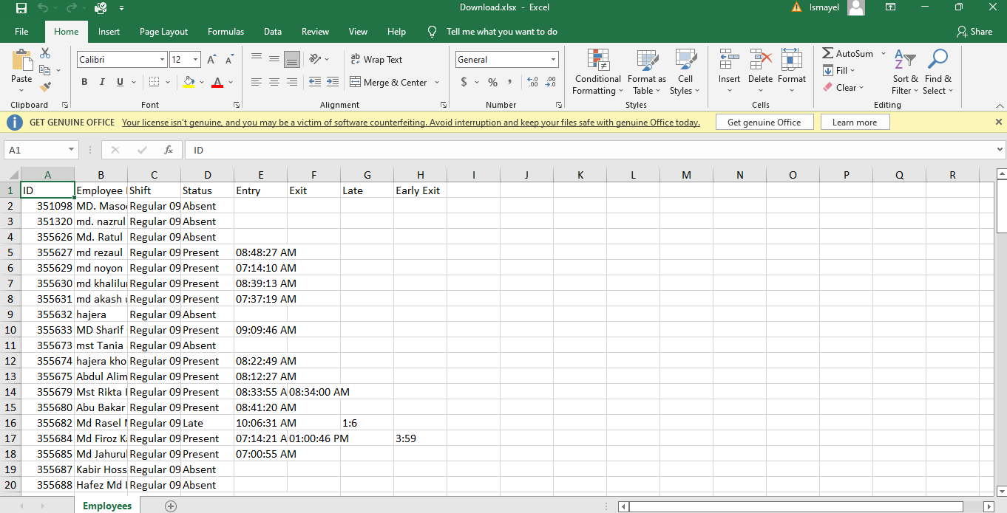

Figure : Daily Department Report downloaded excel file

**Daily Report :**Clicking on **Administration > Human Resource > Tipsoi > Report>Daily Report** .This sub-menu shows the daily attendance report & allows to search to find specific attendance data. Also, this sub-menu provides download daily report file as excel.

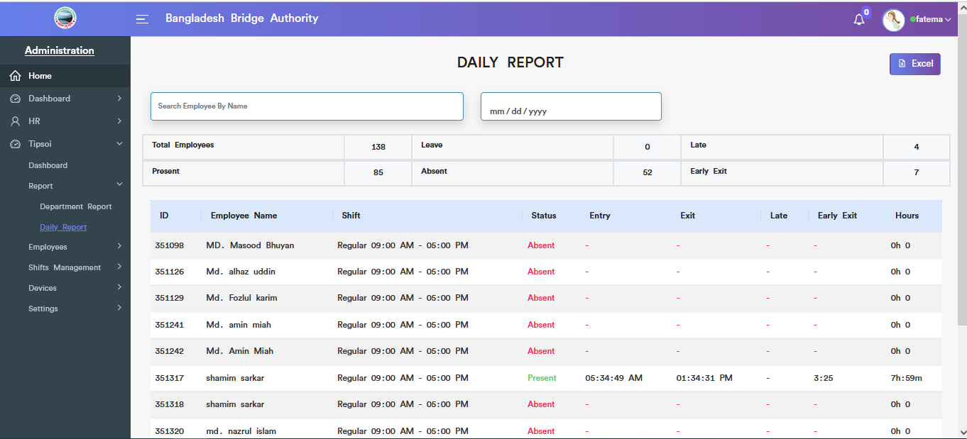

Figure : View Daily Report

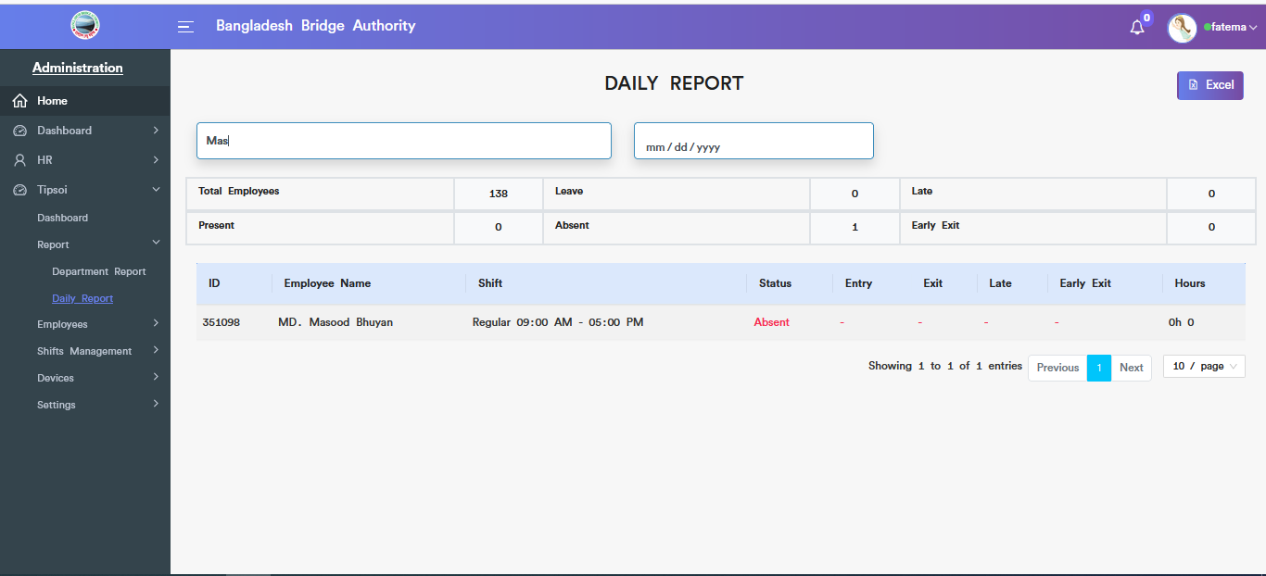

Figure : Search Daily Report

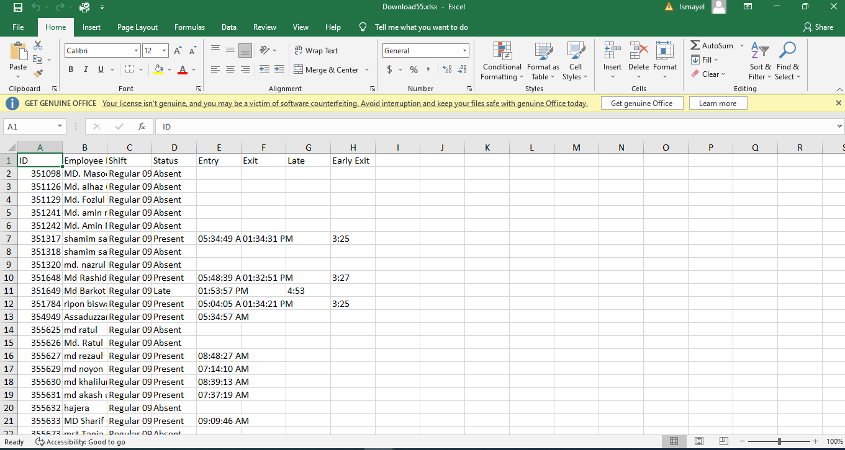

Figure : Downloaded Daily Report excel file

**Employee Information Report :**Clicking on **Administration > Human Resource > Tipsoi >Employees>Employee Information Report** .This sub-menu gives the all employees personal and official information

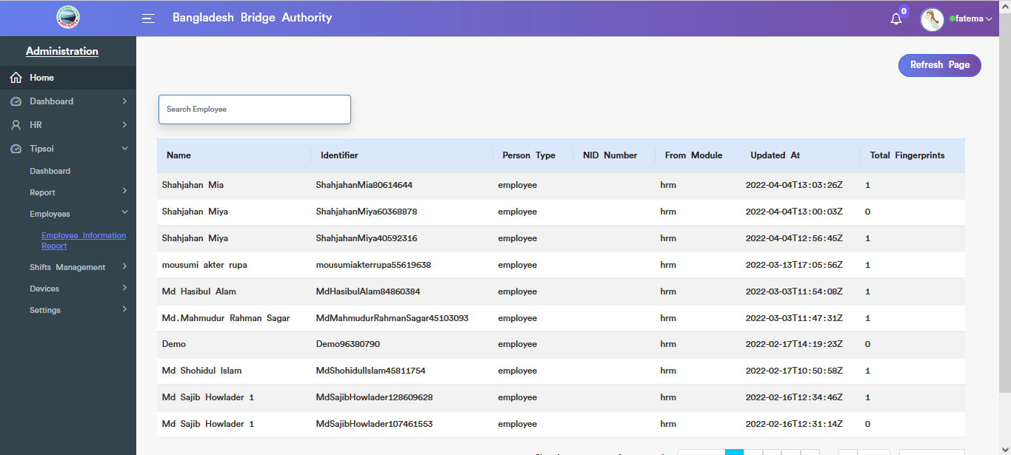

Figure : View employee information report

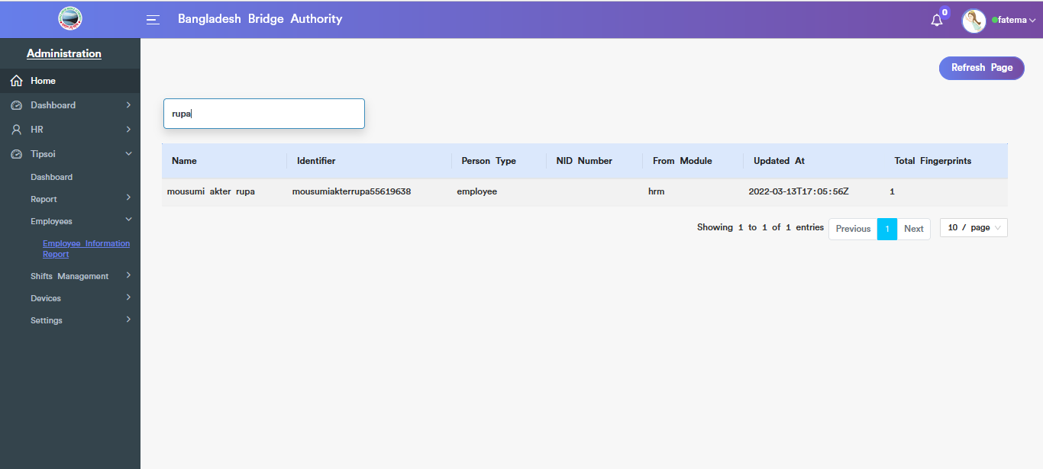

Figure : Get specific employee all information using the search option

**Shift :**Clicking on **Administration > Human Resource > Tipsoi >Shifts Management>Shift** .This sub-menu show the shift information.

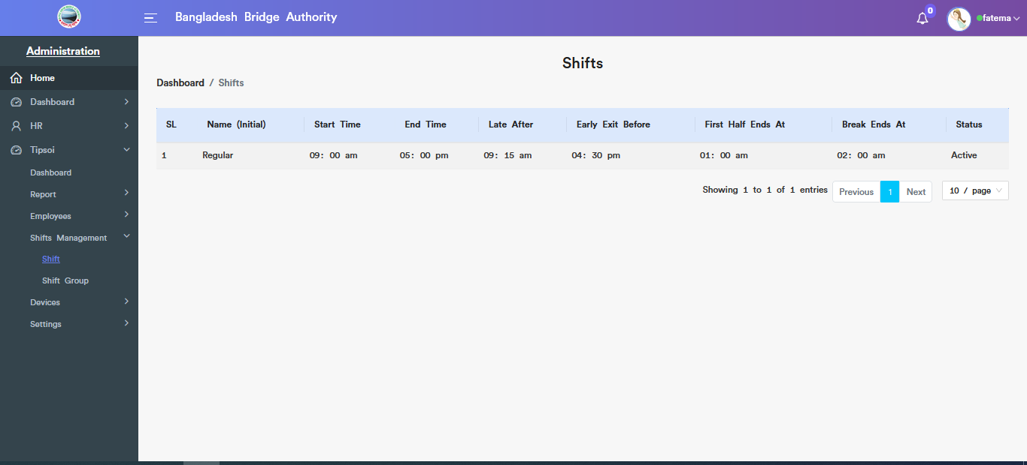

Figure : View of shift information

**Shift Group :**Clicking on **Administration > Human Resource > Tipsoi >Shifts Management>Shift Group** .This sub-menu show the shift group information.

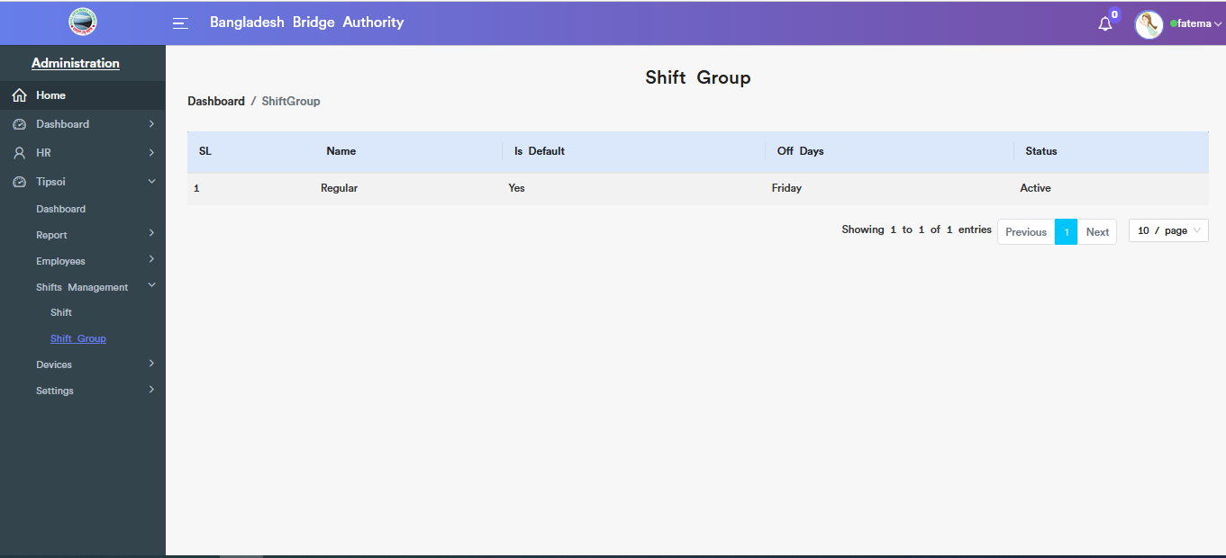

Figure : View of shift group information

**Device List :**Clicking on **Administration > Human Resource > Tipsoi >Devices>Device List** .This sub-menu show the device list information.

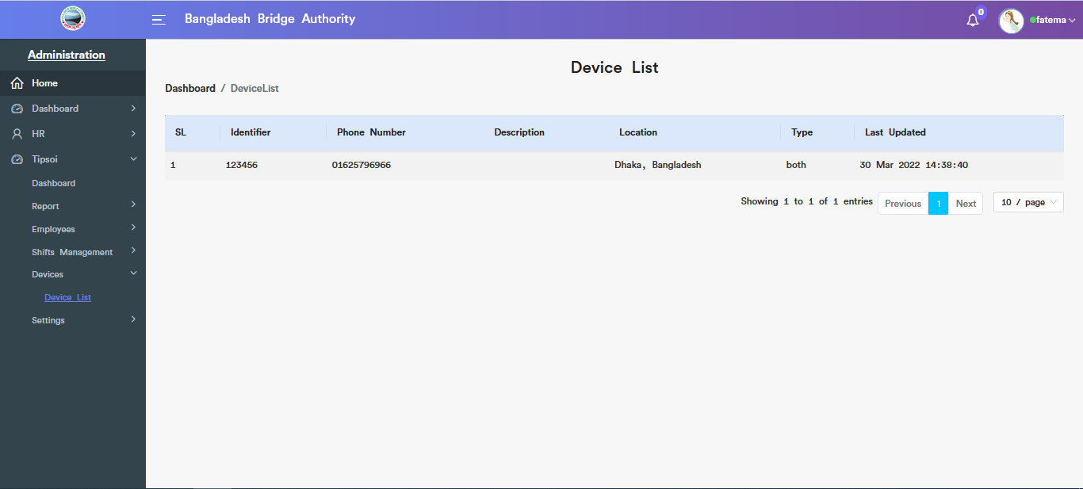

Figure : View of device list information

**Designations :**Clicking on **Administration > Human Resource > Tipsoi >Settings>Designations** .This sub-menu show the designations information.

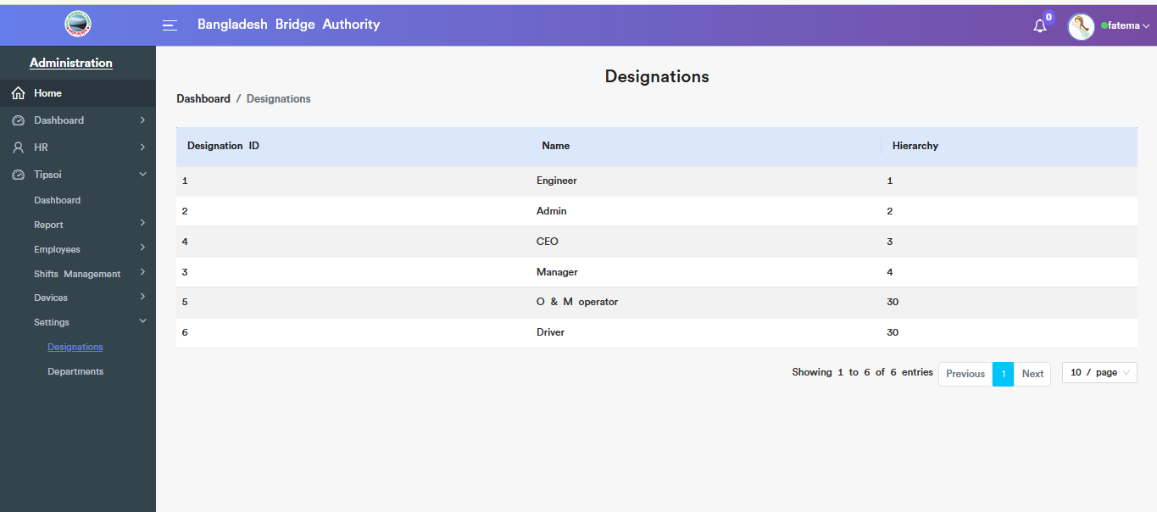

Figure : View of designations information

**Departments :**Clicking on **Administration > Human Resource > Tipsoi >Settings>Department** .This sub-menu show the departments information.

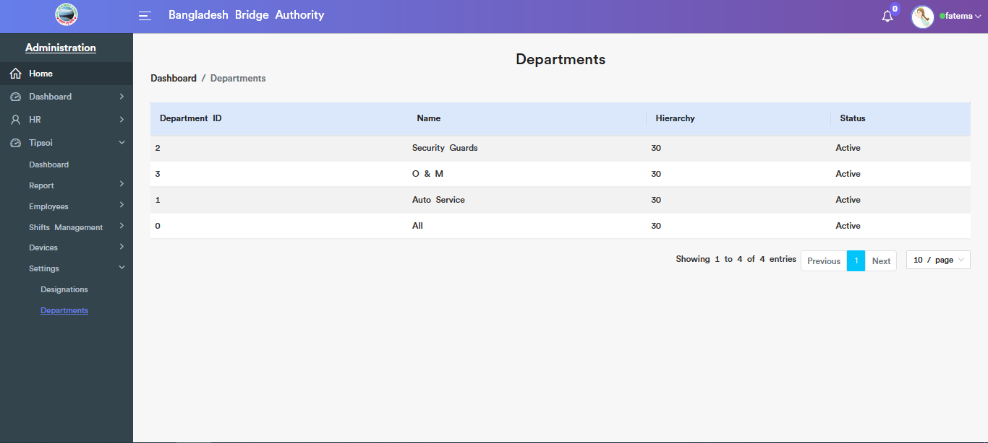

Figure : View of Departments information